Service Description and Outcomes

Lot 2 – Applications Management

Issue Date: 07/07/2025

Table of Contents
1.0 Introduction 3
1.1 Company Overview 3
1.2 Strategic Objectives 3
2.0 Overview of our Partnership Requirements 4
2.1 Overall Vision 4
2.2 Overview of the Lotting Structure and Scope 5
3.0 Service Integration and Management (SIAM) 6
3.1 Underpinning SIAM Principles 6
3.2 Service Integration and Management (SIAM) Requirements 12
4.0 Digital Experience Centre (DEC) 14
4.1 Digital Experience Centre Overview 14
4.2 Service Outcomes 14
4.3 Service Environment - Scope of the Business to Be Supported 19
4.4 Microsoft 365 Support - Introduction 27
4.5 Microsoft 365 Support – Requirements 29
4.6 Common Service Requirements 31
4.7 Digital Experience Centre Requirements 43
5.0 Applications Management 46
5.1 Service Overview 46
5.2 Service Outcomes 46
5.3 Service Environment 50
5.4 Application Overview 61
5.5 Integration Overview 75
5.6 Service Descriptions, Roles and Responsibilities 79
5.7 Product Relationship Specialist Team 84
5.8 Product Relationship Specialist - Requirements 85
5.9 Digital Platform Team 86
5.10 Digital Platforms Team- Requirements 88
5.11 Device Management Services 89
5.12 Device Management Services- Requirements 90
5.13 Corporate Data & Compliance 92
6.0 Service Measures - Service Level Requirements 95

- Introduction
  - Company Overview
Scottish Water’s purpose is to support a flourishing Scotland by being trusted to care for the water on which Scotland depends. We are proud to provide water and waste water services that are essential to everyday life for households and businesses across Scotland. We make a critical contribution to Scotland’s health, well-being and prosperity, the sustainability of our natural environment, and our country’s long-term economic success.
  - Strategic Objectives
Scottish water will fulfil its purpose by pursuing three strategic objectives:
Service Excellence
Adapting to climate change, dealing with our ageing assets and meeting customers' evolving expectations.
This involves:
- Delivering consistently excellent water.
- Transforming wastewater services.
- Enabling sustainable and inclusive growth.
- Empowering customers and communities.

Beyond Net Zero Emissions
Showing leadership in mitigating climate change and enhancing Scotland's natural environment.
This involves:
- Transforming our emissions.
- Embracing the circular economy.
- Enhancing the natural environment.

Great Value & Financial Sustainability
Customers will receive great value, now and in the future, and we will be financially sustainable.
This involves:
- Keeping services affordable.
- Making smarter investment choices.
- Transforming how we work.

- Overview of our Partnership Requirements
  - Overall Vision
Digital Directorate
Scottish Water Digital Directorate is accountable for delivering Digital and technology services and solutions, data, analytics and associated compliance that deliver measurable value to our core business. To do this, we work closely with our business colleagues to deliver value and support our three strategic objectives. We have delivered on our cloud first strategy and replaced much of our enterprise legacy applications with modern evergreen SaaS solutions, examples include but are not limited to Salesforce, Microsoft Dynamics, Workday, Oracle Fusion, Oracle EPM, Oracle Primavera, Copperleaf and IBM Maximo. We have invested in Microsoft Azure as our primary cloud platform where we build and run innovative solutions, data & analytics products for our business. Analytics, data engineering and data science are central to Digital directorates offerings, Azure Lakehouse and Microsoft Power BI are the principal technologies for delivering data, analytics and digital products and services. Data and Information Management including privacy and public records compliance is a central Digital directorate capability. Scottish Water is modernising our network offerings, our strategy is to move to a software defined network approach with wi-fi first connectivity at our office sites.
Our Needs from the Market
Building on this and to support emerging business, customer, and regulatory requirements Scottish Water need a digital supply chain that enables expedient solutions delivery whilst supporting the ongoing maintenance and evergreening of our infrastructure, through recognised industry best practice that is compliant with the data and technology regulations that apply to a public body in the water industry.
The convergence of IT and OT has accelerated as our assets become increasingly connected to the internet using a growing array of sensors and driven by opportunities to enhance service, reduce cost and carbon emissions via an intelligent asset base. In doing so, the solutions we employ must comply with Network & Information Systems (NIS) directive. Supplier arrangements that seamlessly integrate these complex and high-scale digital innovations with engineering practices across capital investment are essential and we are exploring how such arrangements can align with the 'enterprise' model described here: https://www.project13.info/about-project13/
Scottish Water are looking for supplier arrangements which operate at scale, with demonstrable breadth of experience, portfolio and subject matter resources, as well as the ability to manage a wider supply chain where required. Within this we may also be looking for direct interaction with niche suppliers where necessary. We require a supply chain that delivers knowledge, expertise of modern technology, provides access to innovation, and can act as both integrator and expert adviser on Artificial Intelligence (AI), automation, digital twins and other relevant technologies. Scottish Water's intention is to build supplier relationships with those who have a clear strategy and methodology which supports and develops modern engineering practices such as Platform Engineering, DevOps, CI/CD, Automation, Software Defined Networking, Zero Trust, IT/OT convergence and who are capable of continuously implementing technology transformation in a secure way.
Scottish Water requires access to digital skills as well as product, programme and project support in a flexible way to achieve objectives under its Digital Strategy, whilst building relationships with suppliers who can partner in maturing our digital strategy, and implementing and transferring knowledge, as well as leveraging frontier technology.
  - Overview of the Lotting Structure and Scope
Scottish Water is seeking partners to work with us in the following areas which align to the offerings we will put to the market.
Networks and Security (MSA Agreement)
We intend to engage a single partner for converged network and security services in line with our approach to adopt software defined networking. This lot also includes requirements for interim on-premises data centre support and outline requirements and volumetrics have been provided to assist with offers for this ongoing area of services
Applications Management (MSA Agreement)
Service in includes applications management for core line of business applications along with a service that supports business critical azure cloud applications, data products and analytics solutions and a service that supports the M365 platform and its components.
Operational Technology (Framework)
This framework will provide the capability to support both our capital delivery programmes and transformation programmes to assure and deliver modern digital OT solutions in line with our OT strategy.
Digital Transformation (Framework)
This framework will support our digital portfolio and transformation portfolio in delivering and enhancing digital solutions across our existing applications estate and where appropriate introducing new technologies that support our transformation and Scottish Water corporate objectives.

- Service Integration and Management (SIAM)

Scottish Water will bring together both internal teams and external vendors together in a seamless end to end Digital Service. Ensuring quality service provision and integrating services from different partners into a unified experience for all Scottish Water departments.
It is important to Scottish Water that our Digital objectives align and facilitate our overall organisational goals and objectives. Therefore, alongside the operational alignment of services to provide the best service to our business users there is also a strategic governance view, ensuring alignment with organizational goals and consistently improving service delivery.
Scottish Waters internally delivered SIAM model will function on 2 layers, or perspectives. Operational and Strategic Governance.
Figure 1
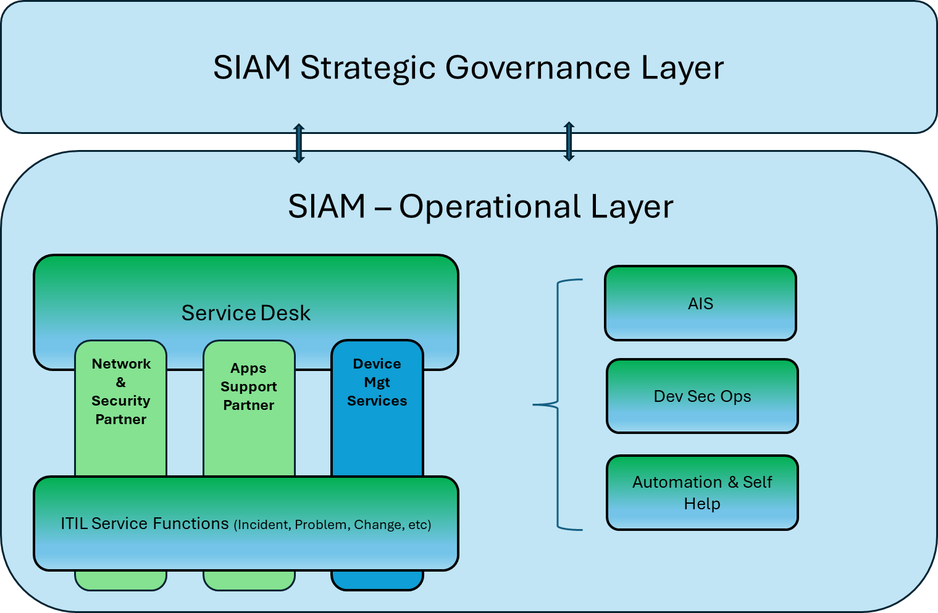

  - Underpinning SIAM Principles

ITSM

Service integration and management spans the entirety of the service lifecycle, starting from initial design. It incorporates ITSM processes as defined by ITIL, and progresses through demand management, project and service portfolio management, extending into operations.
Scottish Water recognises that the world of service delivery can no longer singularly be concerned with ITIL principles, and that the organic growth of Dev Sec Ops and other methods of agile delivery require a tailored approach. Scottish Waters SIAM team will act as the service catalyst no matter which delivery method is utilised. Partners are expected to bring market knowledge and skilled expertise to the fore and act as a willing thought partner as the challenge between fast and agile delivery meets the requirement for security and serviceability in a regulated environment.
Toolset

Scottish Water mandate the use of the ServiceNow Toolset - managed by Scottish Water - fully adopted by service partners
A key element in the SIAM operating model is the capability to establish a unified data source and automate workflow using a toolset across the full-service operating model.
Scottish Water will operate as custodians of a ServiceNow instance that will provide a single source of truth for data and process. Partners will access the toolset and follow process enabling accurate and efficient data use.
It is recognised within Scottish Water that accurate data is fundamental to the effectiveness of the toolset and all associated working process.
Partners are expected to bring market knowledge and skilled expertise to the SIAM function in taking ownership and accountability in professional and effective use of the toolset in line with process.
Zero Preventable Incident Culture

There are so many toolsets capable of monitoring, analysing, diagnosing, self-healing, and predicting, that the meaning of providing a quality service has shifted from how you respond to an incident to now taking action in preventing the incident from occurring in the first place.
Scottish Water Digital Service target ourselves on having as few preventable incidents occur in any given month. This is a target which will be continually reviewed. This will be measured by the SIAM team and focused on for discussion each week. All partners must demonstrate how they will deliver against a Zero Preventable Incident Culture.
Automation
Automation is one of the most impactful differentiators in service provision. Scottish Water will maintain a continual focus on how automation is being deployed, and where it should continue to be deployed. Wherever possible, this will be facilitated via the ServiceNow platform. This will work hand in hand with our Zero Preventable Incident ambition. Partners should demonstrate how they would support our ambitions in automation where applicable in the enablement of more efficient and effective service provision.
Self- Help
All internal and supplier service providers are expected to provide material to aid self-help for Scottish Water service users.
This will be an area influenced by how we make information available to users as and when they require it, in an easy to access and easy to consume mechanism. Self-help capability within ServiceNow will be available.
Continual Service Improvement
Underpinning all areas in service, the golden thread throughout is the desire to continue to be improving service provision.
In Scottish Water this is a constant drive. All partners are expected to compliment this approach and bring a continual view as to how to improve.
Engagement
Scottish Waters SIAM team will include managers experienced in service provision and management.
All partners are expected to provide experienced service management engaged in Scottish Water service provision, management and governance. To discuss from a knowledgeable position on the services provided to Scottish Water, and with decision making capability and empowerment to continually improve service.

SIAM - Operational Layer

The main objective of the operational layer of the SIAM function is to deliver seamless high-quality services in a timely manner across all Scottish Water departments on a daily basis.
The scope includes all internal and externally delivered services:
- Network and Security services - Lot 1 Partner
- Application Support services - Lot 2 Partner
- Device Management Services - Internally delivered
- Digital Experience Centre - Hybrid (Lot 2 delivered in hours
& internally delivered OOH)

Daily Service Review (DSR)
Each morning is started with a focused session on status. The meeting has representation across the Digital Partnership and takes a view on the status of systems (daily checks) and any Major Incidents which have taken place overnight or over the weekend. This is not to be confused with the service desk handover.
All Digital Partners are expected to complete all daily checks, be informed on the status across their service scope (Lot 1 Networks, and Lot 2 Applications), and be prepared to share updates as part of a professional and collaborative approach.
Scottish Water SIAM team will facilitate and lead these sessions, with full input and constructive engagement expected by the Partners.
Major Incident Management
During standard office hours the Digital Experience Centre will be provided by our partner. Out of Hours and Major Incidents will be managed by our internal Scottish Water On Call Duty Managers. An essential aspect of this will be handover.
This should be a seamless service provision to Scottish Water business departments facilitated by accurate use of the toolset, accurate recording of data, and an effective flow of information between In hours and Out of Hours capabilities.
Across resolver teams P1 and P2 calls will be treated as Major Incidents. All Major Incidents must be managed across a 24 x 7 x 365 basis.
Major Incidents will be identified as such by either the Digital Experience Centre (In-hours) or the Duty Manager (at any time). All resolver groups, both internal and partner, must engage with the process (as outlined in the MI Process documentation) providing expertise knowledge and skillset to both the identification and resolution of the MI.
Incident Management
Incidents will be logged and managed within the ServiceNow platform. These will normally be logged via the Digital Experience Centre, self-help capability, or by resolver teams themselves. All assigned resolver teams within all Digital Partners must deliver a timely response and resolution in line with agreed SLAs.
The quality of ticket management and supporting data within ServiceNow will play a pivotal role in driving down incidents and allowing for the adoption of Artificial Intelligence so supporting the introduction of advanced self-help knowledge management and automation. AI is only as good as the data it learns from and how ensuring high-quality data is essential for building trustworthy and effective AI systems. AI development depends entirely upon data, which determines the level of accuracy within an AI model system and ServiceNow is no different.
All Digital Partners and resolver groups have a responsibility within this space. Scottish Waters SIAM team will engage with all partners on the quality of this as a key deliverable monthly.
Problem Management
The internal Scottish Water SIAM function will lead a weekly Problem Management forum attended by SMEs from relevant support areas to identify and eliminate root causes.
This will involve identifying patterns in incidents to uncover underlying problems and collaborating with technical teams to resolve identified problems. Additionally contributing to the documentation of known issues in the knowledge base.
All Digital Partners and resolver groups have a responsibility to bring skillset and expertise to the table and work in partnership to achieve results.
Change Management
Scottish Water will operate a central Change Management function to reflect all changes proposed across the live estate.
Scottish Water work hard to maintain a zero-disruption target when implementing change across the estate. All Digital Partners must prepare documentation to submit, be prepared to discuss at a weekly Change Advisory Board (CAB), and only then proceed with implementation if approval has been granted at that Board.
Digital Partners must attend both from an overall awareness perspective and be prepared to follow and respect Scottish Waters Change Process.
License Management
Each Partner will be responsible for License Management across the scope of their Lot and will contribute to the development of Scottish Water’s Applications License Management processes (This will be established during Service Transition), thereafter maintain License inventories, fully accessible to Scottish Water.
JSR – Monthly Joint Service Review
A view of the service performance will be presented for discussion across the partnership on a monthly basis. Ensuring SLAs and KPIs are achieved and any challenges addressed.
Reporting will be from the core platform ServiceNow, reviewed together and discussed as a partnership.
Service Escalations
With an overarching view across service and all components, the SIAM model will engage in service escalations received from the Scottish Water business. All partners are expected to provide information, and expertise as required as part of service escalations, and to address these in line with the process agreed as part of contractual engagement.
Service Reporting
The backbone toolset for our digital services is ServiceNow. Based on accurate data and workflows, reporting will be set up in the system to enable efficient and accurate MI. Scottish Water are embarking on a project currently with ServiceNow to update our systems in line with how our services are adapting. ServiceNow will be set up with dashboard views for those managing the service across all partners, and reporting capability for accurate reporting to support the operational needs as well as the MI reporting needs.
Digital Customer Experience Measure (DCEM)
The SIAM Team will lead a Monthly DCEM forum working with the partnership to discuss how our Digital Success Measures are directly supporting our business performance measures and reporting areas so we can demonstrate how we contribute towards the overall performance and success of our Business.

SIAM - Strategic Governance Layer

Scottish Waters SIAM model takes service provision beyond statistics and performance measures. It takes a view across the MI and feedback to steer the service in an ever-improving direction. Acting as the facilitator or glue keeping each of the service components operating efficiently together and in line with the business needs.
This involves understanding how all our moving parts are working together, in a coordinated and cohesive manner, to provide a quality end-to-end seamless service provision we are proud of. Partners must engage with appropriate skillset and expertise to input successfully for all parties.
SIAM governance will also consider where services need to adapt or change.
The SIAM team will consider the following areas:
Service Processes
Does the end-to-end service flow as intended? If not, we ask ourselves why not and work to improve. We will look at MI from ServiceNow and feedback from customers.
Where are the service challenges? Are there areas that are causing challenges, if so, how do we improve? Actions will be recorded and tracked. And if required Service Improvement Plans will be initiated and managed
Engagement is required from all partners to make this work across all elements of service provision. Partners must demonstrate how they would commit to this process.
Strategic Objectives
The SIAM governance capability will ensure that services are keeping in line with our strategic objectives. Updating our service in line with changing environmental factors.
Where adjustments need to be considered the SIAM team will engage with appropriate partners and internal commercial teams to bring this forward.
Digital Partners are required to input with skills and expertise to this process. Quarterly reviews will take place to focus on strategic direction and highlight where improvements can be made, where challenges need to be addressed, and where the service is heading.
New Services
The SIAM team will assess where new services are required to be put in place. This may be for new or replacement systems via our Acceptance Into Service Process via Project governance, or because of a changing or emerging business need.
Risk Management
The SIAM team will document, assess and manage service risk. This will feed into the wider Scottish Water internal risk process from a Digital perspective.
Forums
Governance layer will operate as an oversight function supporting the daily operational layer on a continual basis.
However, once a quarter there will be a strategic session set up across the partnership to consider the holistic view of service across Scottish Water. This will be a session covering the topics displayed above with a strategic mindset. Taking stock of where the service is at, how it is performing, what projects and initiatives are shaping the service, and our direction of travel. All partners must demonstrate how they would participate and support this function.

  - Service Integration and Management (SIAM) Requirements
Service Descriptions and Roles and Responsibilities
The following Table 1 describes the detailed responsibilities of the Lot 2 provider together with the Lot 1 provider and Scottish Water responsibilities required to deliver SIAM. (R = Responsible; C = Consulted, I = Informed; A = Accountable).

Table 1
Service Integration and Management (SIAM) | Scottish Water | Lot 2 | Lot 1
Implement a Service Integration and Management (SIAM) function that will manage the partners and integrate them to provide a single, cohesive Digital service delivery to Scottish Water. | A/R | C | C
Coordinate and integrate Digital services from the partners ensuring overall service delivery meets Scottish Water requirements. | A/R | C | C
Clearly defines roles and responsibilities, reducing confusion ensuring accountability for each task. | A/R | C | C
Streamlines communication and decision-making processes and aligns service delivery with Scottish Water business objectives. | A/R | C | C
Implement, manage and measure the Digital Customer Experience Measure (DCEM). | A/R | C | C
Performance Management - Monitor, analyse and manage the performance of the partners against agreed-upon service level agreements (SLAs). | A/R | C | C
Major Incident and Problem Management - Manage issues across the partner landscape, ensuring timely resolution and minimising the impact on the business. | A/R | C | C
Change enablement/management - Overseeing, approving, and coordinating submitted changes across different partners to ensure minimal service disruption | A/R | C | C
Risk Management - Monitoring the service and partner landscape for potential risks and implementing appropriate controls and contingency plans. | A/R | C | C
Demand Management - Managing and influencing the demand for services and ensuring that the various service providers can scale up or down as required. | A/R | C | C
Implement and lead on the ITSM Tools - Ensure that the service management tooling is efficiently managing IT services and meeting both the partner and business needs. | A/R | C | C
Implement and lead a Monthly Joint Service Review (JSR) - Working with the partners the JSR is a structured evaluation of the performance and quality of our Digital services. The JSR goal is to identify areas for improvement, ensure services meet customer expectations, and enhance overall service delivery. | A/R | C | C
Implement and lead a Daily Service Review (DSR) - Working with the partners the DSR will be attended by SMEs from relevant support areas providing an update on any outstanding high priority incidents and general health overview of ticket backlogs. | A/R | C | C
Implement and lead a Monthly Digital Customer Experience Measure (DCEM) Forum - Working with the partners to develop DCEM Measures identifying areas of improvement and actionable insights. | A/R | C | C
Implement and lead a bi Monthly Knowledge Management Forum - Working with the partners to develop customer self-service identifying gaps in knowledge management, business contextualisation and Automation. | A/R | C | C

- Digital Experience Centre (DEC)
  - Digital Experience Centre Overview
The Service Desk to be known as the Digital Experience Centre (DEC) will be located within Scotland and will operate Monday to Friday 08:00 to 18:00, although partners are asked to provide a cost option for 7*24 also located within Scotland and covering the full scope of services.
The Digital Experience Centre will be the front door into Digital and point of contact between our business and those using Digital products and services through which our users can receive help with their technology questions and issues.
The Digital Experience Centre will encompass a broader range of responsibilities than a traditional help desk, focusing not just on technical troubleshooting but also on proactive preventative maintenance and monitoring in support of our Zero Preventable Incident ambition.
The success of the Digital Experience Centre will not be wholly measured on how well it responded to and fixed an incident but also how well it prevented an incident through the adoption of proactive and preventative activities.
Scottish Water’s ServiceNow instance will be at the heart of the Digital Experience Centre exploiting its automation, knowledge management and AI capabilities.
Working in partnership with the internal Scottish Water Service Integration and Management (SIAM) function the Digital Experience Centre will foster the required Scottish Water business contextualisation, which will help the Digital Experience Centre relate to and understand the need and criticality of the requirement of the Scottish Water Business.
A key success for the Digital Experience Centre will ultimately be measured against how many incidents are prevented and how many of our users were able to resolve their own issues. This will inform whether we are heading in the right direction or not.
  - Service Outcomes
Partners shall meet the following key high-level service outcomes related to the Digital Experience Centre.
Proactive Preventative Maintenance & Monitoring
The Digital Experience Centre will adopt our “See Everything, Fix Anything” ambition by exploiting our monitoring tools NexThink and Microsoft Intune Advanced Analytics, proactively identifying employee experience issues before they become IT problems.
These tools will enable unparalleled visibility into issue detection, diagnosis and remediation across all endpoints to improve employee experience, where the Digital Experience Centre will take proactive actions to remedy red flags as soon as they are visible.
We envisage the Digital Experience Centre will conduct outbound engagements to remedy issues where required rather than waiting on an inbound call from our users.
Scottish Water would welcome partners proposing additional initiatives that will support proactive preventative maintenance and monitoring capabilities at the Digital Experience Centre.

Incident Management
The Digital Experience Centre will act as the first point of contact for all incidents. It will log, categorise, prioritise, fix and assign incidents to ensure that critical issues are addressed swiftly.
The quality of ticket management and supporting data within ServiceNow platform will play a pivotal role in driving down incidents and allowing for the adoption of Artificial Intelligence. Thus supporting the introduction of advanced self-help knowledge management. AI can only be as good as the data it learns from and how ensuring high-quality data is essential for building trustworthy and effective AI systems. AI development depends entirely upon data, which determines the level of accuracy within an AI model system and ServiceNow is no different.
Partners should clearly recognise this AI challenge and ensure their proposed service offering has the correct level of expertise to provide valuable and accurate data within ServiceNow platform be that categorising the incident and or request correctly through to providing intuitive remedy notes every time.
To provide the right digital experience for our users the Digital Experience Centre will leverage collaboration and digital workflow techniques. This will be achieved by exploiting the capabilities of the ServiceNow Digital Workflows and Microsoft Teams support including the virtual agent chat functionality.
We envisage the Digital Experience Centre Agents initiating and resolving cases with AI-based recommendations via knowledge articles and bringing stakeholders together via video calls to resolve major incidents. All within the context of a case directly in Microsoft Teams, chatting with a virtual or live agent in Microsoft Teams.
Application User/Functional Support
The Digital Experience Centre will assist customers with the effective use of software applications and ensuring these applications meet their business needs.

The Digital Experience Centre will be knowledgeable across all the Digital enabled business processes and Microsoft 365 products within Scottish Water helping customer to navigate and utilise applications effectively through to addressing user-reported issues and providing solutions.

The Digital Experience Centre conduct all system administration providing and removing access to systems.

The Digital Experience Centre will identify Scottish Water training needs where trending on specific incidents or request determine such.

Request Fulfilment
The scope of service requests is wholly managed through Scottish Water’s ServiceNow instance with a significant focus currently underway to automate as many tasks as possible prior to contract commencement in 2026. This will include the launch of our new ServiceNow Employee Centre that provides our users with a unified portal to access services, communications, apps, and tasks, therefore boosting productivity and enhancing self-service.
The Digital Experience Centre will handle various user requests, ranging from password resets, application access to software installations, although again we have ambitions to have as many of these tasks automated to ensure efficient request fulfilment.
During the design of our new ServiceNow Employee Centre we will develop personalised content to employees based on profiles for location, role, and job type so reducing the request footprint thus providing a great experience and we expect the successful partner to contribute to the maintenance and enhancement of these personalised personas ongoing in partnership with our internal Scottish Water SIAM function.
Business Contextualisation
Our vision for the Digital Experience Centre is one that is high-performing and not merely a pass-through support centre; it will be the pulse that keeps Scottish Water’s Digital operations smooth and our users happy. Beyond troubleshooting, the Digital Experience Centre will cultivate trust, amp up productivity, and ensure every interaction is a positive experience.
This will be achieved by embedding business knowledge (water utility domain information, Scottish Water Digitally enabled business processes etc.) within the Digital Experience Centre as this will be key in ensuring all contacts get understood and get categorised correctly.
We will work together to introduce automated Ticket categorisation (Workflows to automatically categorise tickets based on certain parameters) and automated assignment of tickets. Additionally, our internal Scottish Water SIAM function will work closely with the Digital Experience Centre on a regular basis to educate and pass knowledge ensuring that every aspect of Digital at Scottish Water is understood and put to good use.
Ticket Management
As outlined the Digital Experience Centre will be the front door into Digital and point of contact between our business and those using Digital products and services through which our users can receive help with their technology questions and issues.
A key improvement for our service in 2026 is how we manage chase calls as these cause significant cost and quality issues. If users are calling to ask for an update on the status of their incident or service request what this tells us is that the Digital Experience Centre has not been communicating with them effectively. A chase call means that both the user and the Digital Experience Centre are putting time and effort into doing something that should not have needed doing.
Obviously, automation via email status or Teams Message at regular intervals will aid updating users on the status of their incident or request in addition to providing users access to check the status of their outstanding calls via the ServiceNow portal. Our expectation is the Digital
Experience Centre will own every engagement, working with all resolver teams to ensure effective communication for every engagement.
Partners should design their Digital Experience Centre for experience, keeping it simple and collaborative.
Problem Management
The Digital Experience Centre will work closely with the problem management teams to address recurring issues by identifying and eliminating root causes. This will involve identifying patterns in incidents to uncover underlying problems and collaborating with technical teams to resolve identified problems. Additionally contributing to the documentation of known issues in the knowledge base.
The internal Scottish Water SIAM function will lead a weekly Problem Management forum attended by SMEs from relevant support areas and the Digital Experience Centre will contribute to this forum providing their input into problem identification, classification, root cause analysis, solution identification, and resolution.
Knowledge Management
A key improvement for our service in 2026 is providing our users with high quality intuitive knowledge so they can self-serve. As described under Incident Management getting the data accurate at the Digital Experience Centre will enable the exploitation of AI that will significantly aid the introduction on Knowledge.
Scottish Water’s ServiceNow instance provides a Knowledge Management module that allows our service operations to capture, manage, and share knowledge. It provides a centralised repository for all Digital knowledge, enabling teams to create, review, and publish articles and other content.
The Digital Experience Centre will increase self-service rates for users and leverage the contextual knowledge, powered by AI to boost their agent’s productivity.
Major Incident Management
The Digital Experience Centre will engage with the internal Scottish Water SIAM function for all high-priority incidents that require an immediate response from our incident management teams.
The Digital Experience Centre will play a pivotal role in how often we will communicate with stakeholders throughout the incident. The goal of initial internal communication will be to focus the incident response on one place and reduce confusion. Then the goal of external communication is to tell our customers that we know something’s broken and we are looking into it as a matter of urgency.
Speedy, accurate communication will help build and keep customer trust in our Digital Services.
Customer Experience
The Digital Customer Experience Measure (DCEM) will be our key tool for measuring how well we're serving our customers.
It's all about understanding what our customers think and using that insight to make our services better. By doing this, we aim to consistently deliver a great experience.
Measuring the digital customer experience is crucial for understanding how customers interact with our Digital environment and identifying areas for improvement.
DCEM will be measured against 6 quantitative measures each having their own target where each component will have an aggregated percentage that calculates the overall DCEM score as outlined within the following diagram:
Figure 2
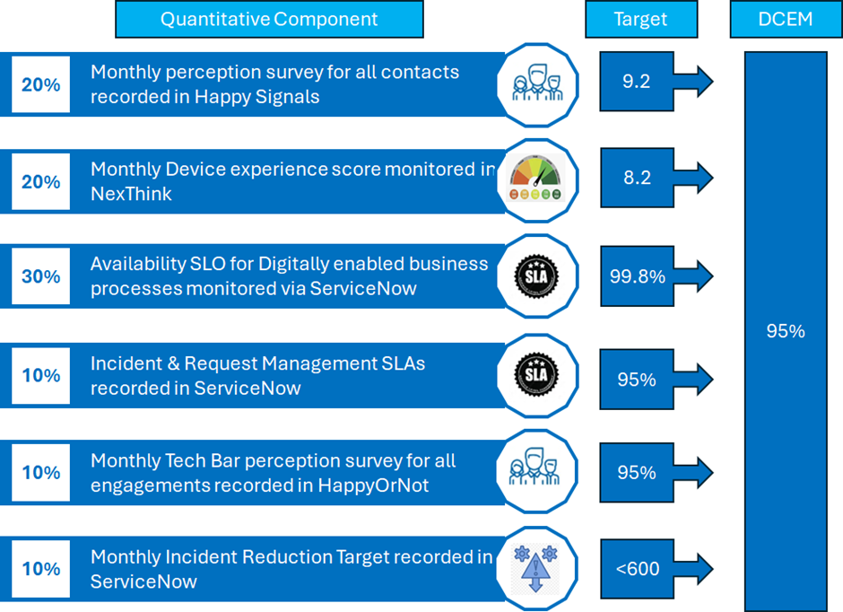
Monitoring and Reporting
The Digital Experience Centre will monitor operations continuously to identify areas for improvement. They will promote feedback to all resolver teams ensuring quality data is being inputted into ServiceNow and that SLA compliance and DCEM measures are being achieved.
The internal Scottish Water SIAM function will lead a daily service review (DSR) attended by SME’s from relevant support areas and the Digital Experience Centre will contribute to this review providing an update on any outstanding high priority incidents and general health overview of ticket backlogs.
The Digital Experience Centre will provide a monthly report to the internal Scottish Water SIAM function detailing their performance against contracted measures. The format and content will be agreed with the internal Scottish Water SIAM function during transition.
  - Service Environment - Scope of the Business to Be Supported
Digital Estate
The following chart provides key service design volumetrics:
Table 2
Key Service Design Areas
Digital Estate | Volumes
Employees (inc Partners / Supply Chain) | 6100
Offices/Depots | 74
Treatment Works | 1031
Laptops | 4920
Desktops | 13
Tablets | 1206
Mobile Phones | 3161
Enterprise Applications | 16
Small Direct to Vendor Applications | 113
Azure Applications | 94
Power BI Reports | 4334
IT/OT Network Conections | 10000+
Incident Management Volumes
The current Service Desk processed 11431 Customer Incidents over the last 12 months, and these are categorised across 6 areas as outlined within the following chart:
Table 3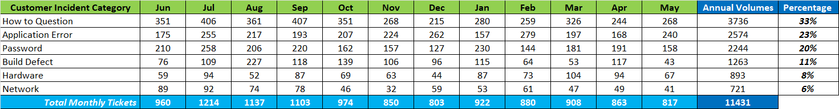
- How to Questions account for 33% of overall annual incidents. These incident types are for customers who have asked a specific question on how to do something that is not fault related.
- Application Errors account for 23% of overall incidents. These incident types are for customers who have encountered an error working within a specific application.
- Password Resets account for 20% of overall incidents.
- Build Defects account for 11% of overall incidents. These incident types are for customers who have encountered an error working with their device.
- Hardware Faults account for 8% of overall incidents. These incident types are for customers who have a fault with a device or peripheral.
- Network Faults account for 6% of overall incidents. These incident types are for failures in the communication protocols that are used to monitor critical operational assets and general BT telephony faults associated with both landline and mobile communications.

Analysis for How to Questions
To provide more insight into the Incidents associated with How to Question over the last 12 months a total of 2686 or (72%) of the 3736 incidents logged annually were associated with the top 10 trending questions as outlined within the following chart:
Table 4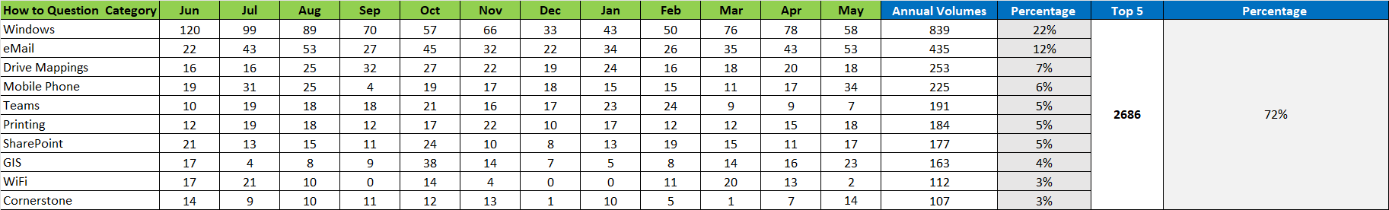
Request Management Volumes
The current Service Desk processed 18616 Customer Requests over the last 12 months, and these are categorised across 6 areas as outlined within the following chart:
Table 5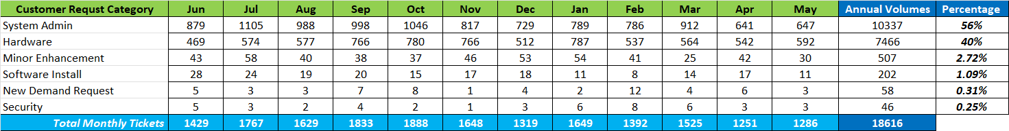
- System Admin requests account for 56% of overall requests. These request types are for customers who need access to systems or are for the recovery of leaver licences
- Hardware Requests account for 40% of overall requests. These request types are for new joiners, leavers, customers changing role or customers who need replacements for peripheral equipment that has come end of life.
- Minor Enhancement requests account for 2.27% of overall requests. These request types are for small changes to applications.
- Software Installs account for 1.09% of overall requests. These requests are for software products that have not been provided to the customer on their device and or are bespoke / niche products required to perform induvial roles.
- New Demand Requests account for 0.31% of overall requests. These request types are for larger changes to applications or technologies.
- Security Requests account for 0.25% of overall requests. These request types are for access to blocked web sites.

Application Change Delivery
Application Minor Enhancement (ME) within Scottish Water refer to small-scale changes or improvements to an application. They also include modifying the application to work with new environments or technologies via new integrations for example.
Additionally, these support enhancements to existing functionality for better performance and usability.
The current Applications Management service processed 421 Minor Enhancements covering 19 different applications that are in scope over the last 12 months as outlined within the following chart:
Table 6
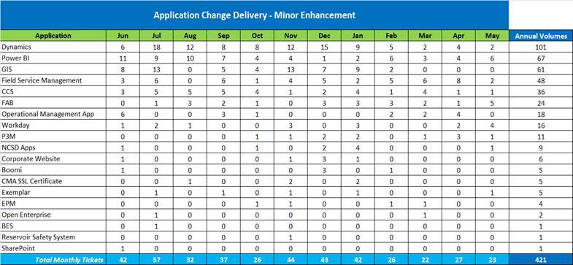
We refer to enhancements that introduce major new features or significant changes to the application core functionality as New Demand.
These changes are reviewed individually from a cost, time and effort to implement along with the supporting benefits the change would introduce.
The current Applications Management service processed 32 New Demands covering 9 different applications that are in scope over the last 12 months as outlined within the following chart:
Table 7
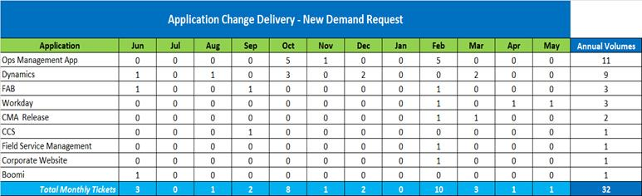
Contact Channels

The 30034 Contacts associated with Incident and Request Management Services processed through the current Service Desk over the last 12 months have been raised via 6 different channels as outlined within the following chart:

Table 8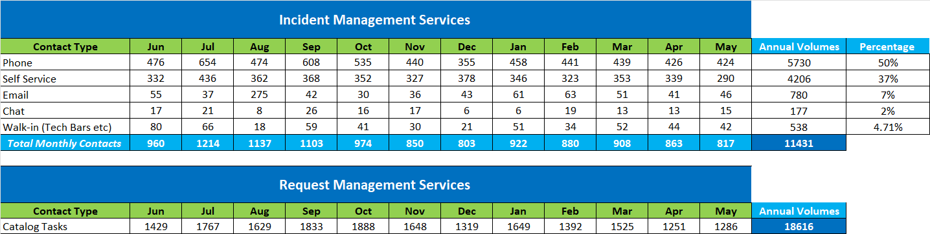
Note all Requests are processed via the ServiceNow Service Catalogue.
A total of 6455 contacts (21% of all contact types) processed through the current Service Desk over the last 12 months were chase and update calls from customers looking for a status on their Incident or Request as outlined within the following chart:

Table 9
Inbound Demand Window
The peak service window for raising incidents and requests is between 08:00 and 15:00 Monday to Friday covering 70% of all activity or 78% of all activity between the hours of 08:00 and 18:00 Monday to Friday as outlined within the following chart:
Table 10
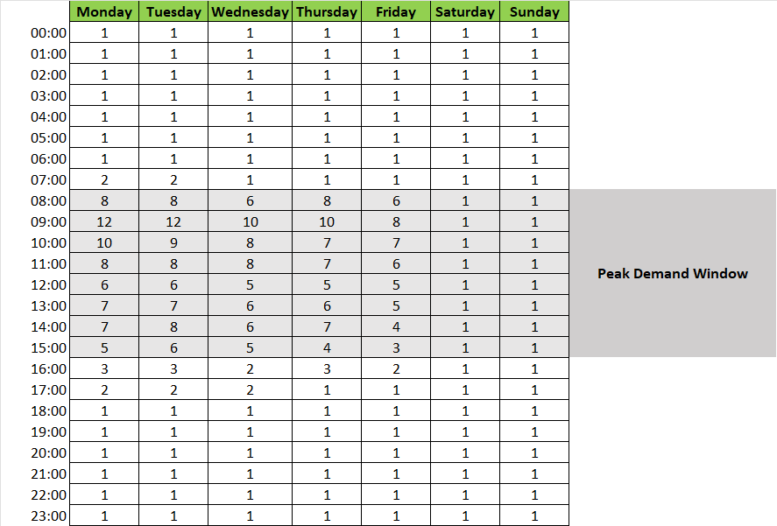
Vendor Support
The Digital Experience Centre will be accountable for logging, triaging and managing incidents or queries for 113 applications that Scottish Water categorise as “Cloud Apps Direct to Vendor”.
These are bespoke software solutions (AKA COTS - Commercial Off The Shelf) that Scottish Water leverage to digitise, automate and simplify our business processes.
The Digital Experience Centre will maintain knowledge articles for all these applications allowing them to answer simple customer queries that are not associated with an incident.
Scottish Water’s internal Product Relationship Specialist Function will monitor all vendor applications for certificate renewals, enhancements and compliance with our security and data policies and engage with the Digital Experience Centre on any areas of change they need to be made aware of.
These applications are outlined within table 11 below.
Table 11
Name | Category | Vendor | Support Hours
2Go | Cloud App Direct to Vendor | iNovar | 9am-5pm (Mon-Fri)
Abriska | Cloud App Direct to Vendor | URM Consulting Services | 9am-5pm (Mon-Fri)
Achilles | Cloud App Direct to Vendor | Achilles | 9am-5pm (Mon-Fri)
Acorn | Cloud App Direct to Vendor | CACI | 9am-5pm (Mon-Fri)
All-Star | Cloud App Direct to Vendor | All-Star | 24*7
Alphabridge | Cloud App Direct to Vendor | Tax Systems | 9am-5pm (Mon-Fri)
Alphatax | Cloud App Direct to Vendor | Tax Computer Services | 9am-5pm (Mon-Fri)
APNRV Maintenance | Cloud App Direct to Vendor | Fulcrum | 9am-5pm (Mon-Fri)
Articulate | Cloud App Direct to Vendor | Omniplex Group | 9am-5pm (Mon-Fri)
Arval | Cloud App Direct to Vendor | Arval | 9am-5pm (Mon-Fri)
Atamis | Cloud App Direct to Vendor | Atamis | 9am-5pm (Mon-Fri)
AVCO | Cloud App Direct to Vendor | Avco | 9am-5pm (Mon-Fri)
BARCO | Cloud App Direct to Vendor | BARCO | 9am-5pm (Mon-Fri)
BES | Cloud App Direct to Vendor | Benchmark Estimating | 9am-5pm (Mon-Fri)
Bing Maps | Cloud App Direct to Vendor | Microsoft | 24*7
BowTie XP | Cloud App Direct to Vendor | Wolters Kluwer | 9am-5pm (Mon-Fri)
BridgeWorx | Cloud App Direct to Vendor | Iconics | 24*7
Building Management System | Cloud App Direct to Vendor | ` | 24*7
CardsOnline | Cloud App Direct to Vendor | Safe Identification | 24*7
Cello Wizard | Cloud App Direct to Vendor | Technolog | 9am-5pm (Mon-Fri)
ChargePlace Scotland | Cloud App Direct to Vendor | The Scottish Government | 9am-5pm (Mon-Fri)
Clarity | Cloud App Direct to Vendor | Clarity Travel | 9am-5pm (Mon-Fri)
Convey Tech | Cloud App Direct to Vendor | Convey Technology | 9am-5pm (Mon-Fri)
Cornerstone | Cloud App Direct to Vendor | Cornerstone on demand | 9am-5pm (Mon-Fri)
Critiqom | Cloud App Direct to Vendor | Adare SEC | 9am-5pm (Mon-Fri)
CSO Aesthetic Survey | Cloud App Direct to Vendor | Fulcrum | 9am-5pm (Mon-Fri)
CSO Cleaning V2.1 | Cloud App Direct to Vendor | Fulcrum | 9am-5pm (Mon-Fri)
DataGate | Cloud App Direct to Vendor | HWM-Water | 24*7
Digizuite | Cloud App Direct to Vendor | Luxion Group ApS | 9am-5pm (Mon-Fri)
Driver Check | Cloud App Direct to Vendor | Eblon Group | 9am-5pm (Mon-Fri)
DTM Portal | Cloud App Direct to Vendor | Direct Tyre Management | 24*7
Dun and Bradstreet | Cloud App Direct to Vendor | Dun and Bradstreet | 9am-5pm (Mon-Fri)
Duradiamond | Cloud App Direct to Vendor | Health Partners | 9am-5pm (Mon-Fri)
Education Tracker | Cloud App Direct to Vendor | Lawlor Technologies | 9am-5pm (Mon-Fri)
Energy Savings Trust | Cloud App Direct to Vendor | Energy Savings Trust | 9am-5pm (Mon-Fri)
ePtW | Cloud App Direct to Vendor | Safetymint | 9am-5pm (Mon-Fri)
ESNET | Cloud App Direct to Vendor | Meteor Communications | 9am-5pm (Mon-Fri)
GAP | Cloud App Direct to Vendor | Gap Group Limitied | 9am-5pm (Mon-Fri)
Get Abstract | Cloud App Direct to Vendor | Get Abstract | 9am-5pm (Mon-Fri)
GoodShape | Cloud App Direct to Vendor | GoodShape | 9am-5pm (Mon-Fri)
Guider | Cloud App Direct to Vendor | Guider | 9am-5pm (Mon-Fri)
Hubeleon CMS | Cloud App Direct to Vendor | Hanger 19 | 9am-5pm (Mon-Fri)
HWM Online | Cloud App Direct to Vendor | HWM | 9am-5pm (Mon-Fri)
ICC Weather Notifications | Cloud App Direct to Vendor | Iconics | 24*7
iDefigo Control Centre | Cloud App Direct to Vendor | iDefigo | 9am-5pm (Mon-Fri)
Key2 | Cloud App Direct to Vendor | Jaama | 9am-5pm (Mon-Fri)
Korn Ferry Pay | Cloud App Direct to Vendor | Korn Ferry | 9am-5pm (Mon-Fri)
Lex | Cloud App Direct to Vendor | Lex Autolease | 9am-5pm (Mon-Fri)
Live Weather | Cloud App Direct to Vendor | Oracle | 24*7
Logotech PSTM | Cloud App Direct to Vendor | Logotech | 9am-5pm (Mon-Fri)
Low Flows | Cloud App Direct to Vendor | Wallingford Hydro Solutions | 9am-5pm (Mon-Fri)
Low Flows Enterprise QUBE | Cloud App Direct to Vendor | Wallingford Hydro Solutions | 9am-5pm (Mon-Fri)
MapInfo | Cloud App Direct to Vendor | Pitney Bowes | 9am-5pm (Mon-Fri)
Matrix | Cloud App Direct to Vendor | Matrix Booking | 9am-5pm (Mon-Fri)
McConnechy Portal | Cloud App Direct to Vendor | McConnechys | 24*7
Meniscus MAP Rain | Cloud App Direct to Vendor | Metasphere | 24*7
Michelin Connected Fleet | Cloud App Direct to Vendor | Michelin | 24*7
MIDPortal | Cloud App Direct to Vendor | MDS | 9am-5pm (Mon-Fri)
MISER | Cloud App Direct to Vendor | Ovarro | 9am-5pm (Mon-Fri)
Moodle | Cloud App Direct to Vendor | Synergy Ltd | 24*7
My Vechicle App | Cloud App Direct to Vendor | Jaama Limited (MAIN) | 9am-5pm (Mon-Fri)
Neptune WSMS | Cloud App Direct to Vendor | M2MCloud | 9am-5pm (Mon-Fri)
Numonix IX Cloud Recording | Cloud App Direct to Vendor | Numonix | 9am-5pm (Mon-Fri)
Onclusive | Cloud App Direct to Vendor | Onclusive | 9am-5pm (Mon-Fri)
Optima | Cloud App Direct to Vendor | Optima Software | 9am-5pm (Mon-Fri)
OrbusInfinity | Cloud App Direct to Vendor | Orbus Software (MAIN) | 9am-5pm (Mon-Fri)
Osprey | Cloud App Direct to Vendor | /Sixt Vehicle hire | 9am-5pm (Mon-Fri)
Palisade @Risk | Cloud App Direct to Vendor | Lumivero LLC | 9am-5pm (Mon-Fri)
PECOS | Cloud App Direct to Vendor | Elcom | 9am-5pm (Mon-Fri)
PeopleSafe | Cloud App Direct to Vendor | SkyGuard | 24*7
Pipe Crossing | Cloud App Direct to Vendor | Fulcrum | 9am-5pm (Mon-Fri)
PMAC | Cloud App Direct to Vendor | Technolog | 9am-5pm (Mon-Fri)
PMAC Lite | Cloud App Direct to Vendor | Technolog | 9am-5pm (Mon-Fri)
Private Meter Survey | Cloud App Direct to Vendor | Fulcrum | 9am-5pm (Mon-Fri)
PSTM | Cloud App Direct to Vendor | Logotech Systems | 9am-5pm (Mon-Fri)
PT-X Cloud | Cloud App Direct to Vendor | Bottomline Technologies | 24*7
PT-X Drive | Cloud App Direct to Vendor | Bottomline Technologies | 24*7
Public Sector Geospatial | Cloud App Direct to Vendor | Ordnance Survey | 9am-5pm (Mon-Fri)
QA Complete | Cloud App Direct to Vendor | SmartBear | 24*7
Qualtrics | Cloud App Direct to Vendor | Qualtrics | 24*7
Rant and Rave | Cloud App Direct to Vendor | Upland Software | 24*7
SearchStax | Cloud App Direct to Vendor | SearchStax | 9am-5pm (Mon-Fri)
SeqView | Cloud App Direct to Vendor | Abyss Soloutions | 9am-5pm (Mon-Fri)
ServiceNow | Cloud App Direct to Vendor | ServiceNow | 24*7
Sewer Cleaning (Network) | Cloud App Direct to Vendor | Fulcrum | 9am-5pm (Mon-Fri)
SHL | Cloud App Direct to Vendor | SHL | 9am-5pm (Mon-Fri)
Situational Awareness | Cloud App Direct to Vendor | Iconics | 24*7
SmartSheet | Cloud App Direct to Vendor | SmartSheet | 9am-5pm (Mon-Fri)
SpheraCloud | Cloud App Direct to Vendor | Sphera | 24*7
SPROUT | Cloud App Direct to Vendor | Sprout Social | 9am-5pm (Mon-Fri)
Storm Kings | Cloud App Direct to Vendor | Fulcrum | 9am-5pm (Mon-Fri)
Strategic Air Valve Surveys | Cloud App Direct to Vendor | Fulcrum | 9am-5pm (Mon-Fri)
SVM Team Risk Assessment | Cloud App Direct to Vendor | Fulcrum | 9am-5pm (Mon-Fri)
SW Splash | Cloud App Direct to Vendor | Rewards Gateway | 24*7
SWIPE | Cloud App Direct to Vendor | Fulcrum | 9am-5pm (Mon-Fri)
Talent 360 | Cloud App Direct to Vendor | Head Light | 9am-5pm (Mon-Fri)
Talogy | Cloud App Direct to Vendor | Talogy | 9am-5pm (Mon-Fri)
TE Pollution Investigation | Cloud App Direct to Vendor | Fulcrum | 9am-5pm (Mon-Fri)
Trade Effluent FOG Investigations | Cloud App Direct to Vendor | Fulcrum | 9am-5pm (Mon-Fri)
Trade Effluent SPRA | Cloud App Direct to Vendor | Fulcrum | 9am-5pm (Mon-Fri)
Tungsten | Cloud App Direct to Vendor | Tungsten | 24*7
UK Telematics | Cloud App Direct to Vendor | MCF | 9am-5pm (Mon-Fri)
Vehicle Operator Licensing | Cloud App Direct to Vendor | DVSA | 9am-5pm (Mon-Fri)
Vision | Cloud App Direct to Vendor | Logistics | 9am-5pm (Mon-Fri)
Water Valve Maintenance | Cloud App Direct to Vendor | Fulcrum | 9am-5pm (Mon-Fri)
WaterCore | Cloud App Direct to Vendor | Technolog | 9am-5pm (Mon-Fri)
Wet Well Cleaning | Cloud App Direct to Vendor | Fulcrum | 9am-5pm (Mon-Fri)
Workiva | Cloud App Direct to Vendor | Workiva | 24*7
Workplace Connect (Planet FM) | Cloud App Direct to Vendor | MrI Software | 9am-5pm (Mon-Fri)
Xylem Avensor | Cloud App Direct to Vendor | Xylem | 9am-5pm (Mon-Fri)
YWYL | Cloud App Direct to Vendor | Mediaworks | 9am-5pm (Mon-Fri)
Zapmap | Cloud App Direct to Vendor | Zapmap Limited | 9am-5pm (Mon-Fri)
Z-One Website | Cloud App Direct to Vendor | Z-Tech | 9am-5pm (Mon-Fri)

  - Microsoft 365 Support - Introduction

Scottish Water is a mature consumer of the Microsoft 365 ecosystem, operating primarily on Microsoft 365 E5 licences with multiple add-ons, including extensive deployment of Microsoft Copilot (currently adopted by ~2,000 users).
Multiple internal teams contribute to the successful use of Microsoft 365 across the organisation. These include specialists in device management, identity governance, Power Platform exploitation, digital skills enablement, and architectural oversight.
However, there remains a clear need for a strategic external partner to provide robust support, administration, governance, and user enablement at scale – including 24x7 incident response and proactive service health monitoring.
This service was previously delivered under a standalone contract with a Microsoft partner. Under the new model, the relevant responsibilities will be absorbed into the scope of this Apps Management Lot, with selected services retained internally (see below).
Scope of External Services
The successful partner will be expected to operate or contribute to a Digital Experience Centre (or equivalent model), providing frontline and specialist support across the M365 suite. The scope includes but is not limited to:
Technical Support & Incident Management
- 24×7 resolution of incidents causing disruption across the Microsoft 365 suite (including Teams, SharePoint, OneDrive, Outlook, Word, Excel, PowerPoint, Power BI, Power Apps, Power Automate, Forms, etc.)
- Support and triage of identity/access issues relating to Microsoft Entra ID (e.g., MFA, conditional access, guest access)
- Break/fix support for critical business reports (Power BI), apps (Power Apps), or automations (Power Automate)
- Support for Teams administration, including policy configuration, device enrolment, Teams apps, and telephony integrations
- SharePoint and OneDrive administration, including permissions, site management, and issue resolution

Platform Oversight & Governance
- Monitoring of Microsoft 365 service health dashboards and incident notifications
- Reporting on licensing usage, application adoption, feature usage, and configuration drift
- Support for governance practices related to the Power Platform:
  - Inventory management of critical apps/dashboards
  - Identification and mitigation of app sprawl or redundancy
  - Support for app review/onboarding practices (e.g., non-Microsoft apps within Teams)
- Proactive assessments of Microsoft roadmap items and updates with impact analysis and actionable recommendations

Training & User Enablement
- Provision of self-help tools and resources (e.g., knowledge base articles, tutorials, FAQs)
- Live assistance via chat or call-back models
- Delivery of tailored training sessions (e.g., monthly drop-ins or webinars) on emerging capabilities (e.g., Microsoft Copilot, Power Platform, Entra ID security best practices)
- Support for a mentoring ecosystem to increase internal capability across business units

Service Delivery & Collaboration
- Seamless collaboration with Scottish Water internal teams and other delivery partners
- Consistent adherence to governance protocols, service delivery processes, and escalation procedures
- Clear ownership of escalated issues via Microsoft Admin Centres, including liaison with Microsoft Premier Support as required
- Contribution to continual improvement of the user experience across all support channels

Professional Services & Specialist Support
- Advice and solution design aligned with Scottish Water’s digital architecture and cyber security principles
- Participation in key governance and review boards when required
- Provision of expert personnel with strong Microsoft accreditation
- Clear role definition between run/support and any additional project/change activities (e.g., tenant reconfiguration, complex rollout projects)

Internal vs External Responsibilities
Table 12
Area | Internal Teams | Partner
Device & Intune Management | Full ownership (incl. policies and provisioning) | Support resolution of M365 alerts tied to device config
Identity Governance | Strategy, policy, conditional access | Support for identity issues affecting M365 services
Power Platform Exploitation | Business enablement, solution development | Run support, incident management, governance support
M365 Adoption / User Enablement | Training materials, community development | Live training, mentoring support, self-help tooling
Copilot Enablement | Use case definition, change management | Technical support, feature guidance, adoption insights
Admin Centres (e.g. Teams/SP) | Shared model – policy control and investigation activities retained internally | Execution of config, monitoring, troubleshooting, and provision of relevant reporting to aid information governance
Service Health & Reporting | Internal analytics integration | M365 admin monitoring, incident triage and reporting
Escalation to Microsoft | Contractual engagement retained internally | Initiate and manage tickets, escalate to SW as required

The partner must demonstrate an ability to work constructively within this federated model, respecting internal accountabilities while ensuring external support is fast, accurate, and adds genuine value.
Transition from Current Contract
The current standalone contract covering M365 and Azure support will expire before this new contract is let. The partner must:
- Propose an onboarding and knowledge transfer plan
- Set out how they will inherit and enhance the support model
- Demonstrate understanding of both tactical and strategic M365 needs in a complex public-sector setting

  - Microsoft 365 Support – Requirements
Service Descriptions and Roles and Responsibilities
The following Table 13 describes the detailed responsibilities of the Lot 2 provider together with the Lot 1 provider and Scottish Water responsibilities required to deliver the Microsoft 365 Support. (R = Responsible; C = Consulted, I = Informed; A = Accountable).

Note: The partner response should:
- Clearly describe how your organisation will deliver 24x7 M365 support in a hybrid internal/external model.
- Outline team roles, SLAs, escalation processes, and customer experience strategies
- Provide examples of where you’ve supported complex M365 estates, ideally including Copilot and Power Platform.
- Articulate your approach to proactive governance and roadmap monitoring.
- Set out your capability to deliver impactful training and user mentoring at scale.

Table 13
Microsoft 365 Support | Scottish Water | Lot 2 | Lot 1
Identity strategy & governance (Microsoft Entra ID) | A/R | C
Intune policy management | A/R | C/I
Incident resolution (M365 apps & services) | C/I | A/R
Teams / SharePoint / OneDrive admin config | A | R
Copilot enablement (use cases, comms, adoption) | A/R | C
Power Platform governance & app inventory | A/R | C/R
Break/fix support for Power Apps / Power BI | C | A/R
M365 service health monitoring & escalation | C/I | A/R
Training, webinars, mentoring support | A/R | C/R
Knowledge base / self-help tooling | C/I | A/R
Change enablement for M365 roadmap items | A/R | C
Documentation & runbooks for support processes | C/I | A/R

  - Common Service Requirements
Service Descriptions and Roles and Responsibilities
The following Tables (14-27) describe the detailed responsibilities of the Lot 2 provider together with the Lot 1 provider and Scottish Water responsibilities which are common to all Services.
(R = Responsible; C = Consulted, I = Informed; A = Accountable).

Table 14
Service Management | Scottish Water | Lot 2 | Lot 1
Continuously identify and implement opportunities for improvement to Services in liaison with the internal Scottish Water SIAM function | I | R | R
Understanding our customer’s business context including their work style, key service priorities, key services being consumed and communicating this knowledge to all delivery partners. | I | R | R
Provide reasonable support to Scottish Water in the development of its IT Strategy through both formal and informal channels, thereby ensuring the Partner provides ongoing access to its broader skills and capabilities as part of its Services to Scottish Water. | I | R | R
Ensure that Partner Personnel are suitably trained, knowledgeable and skilled, that their relevant technical and business process experience is maintained, and they are familiar with relevant Scottish Water policies and procedures. | I | R | R
Continually identify and implement in accordance with the Change Control Procedure opportunities for improvement - reviewing service performance against the Service Levels. | I | R | R
Working with the internal Scottish Water SIAM function contribute to the Monthly Performance Report by providing all key Digital Experience Centre measures | A | R | R
Working with the internal Scottish Water SIAM function to ensure outgoing communications to our customers informing them of outages, service updates and IT related events. Communication with customers shall be sent on their preferred channel, be focused on what the communication means for them and communicated in language that makes sense to them. | C | R | R
Provide a specific point of contact for customers to address any issues or complaints they may have with the Services | C | R | R
Working with the internal Scottish Water SIAM function on customer complaints and areas of bad service (including long standing Problems and escalations) to improve the service and take preventative action to ensure complaints do not reoccur. | A | R | R
Monthly Joint Service Review (JSR) - Working with the internal Scottish Water SIAM function contribute to the JSR that is a structured evaluation of the performance and quality of our Digital services. The JSR goal is to identify areas for improvement, ensure services meet customer expectations, and enhance overall service delivery. | A | R | R
Daily Service Review (DSR) - Working with the internal Scottish Water SIAM function contribute to the DSR providing an update on any outstanding high priority incidents and general health overview of ticket backlogs. | A | R | R
Comply with the internal Scottish Water SIAM Change Management processes | A | R | R
Monthly Digital Customer Experience Measure (DCEM) Forum - Working with the internal Scottish Water SIAM function contribute to the wider development of DCEM Measure identifying areas of improvement and actionable insights. | A | R | R
Weekly Problem Management Forum - Working with the internal Scottish Water SIAM function contribute this forum providing input into problem identification, classification, root cause analysis, solution identification, and resolution. | A | R | R
BI Monthly Knowledge Management Forum - Working with the internal Scottish Water SIAM function contribute to wider development of customer self-service identifying gaps in knowledge management and AI | A | R | R

Table 15
Major Incident Management | Scottish Water | Lot 2 | Lot 1
Leading the response effort, coordinating teams, and acting as the central point of contact ensuring the incident is resolved as quickly as possible and minimising business impact. | A/R | C | C
Logging the incident, communicating with end users, escalating as needed and providing timely updates and ensuring user concerns are addressed. | C | R | R
Diagnosing and resolving the issue by implementing technical fixes and workarounds. | C | R | R
Managing the service continuity process in disaster recovery scenarios ensuring business continuity during major incidents. | A | R | R
Creation of a Major Incident Report (MIR) for every high priority incident documenting the incident occurrence, impact, and resolution ensuring all actions and decisions are documented so providing insights for improving incident management processes. | C | R | R
Participate in post resolution follow ups of Major Incidents to understand customer feedback and identify improvements for the Major Incident Process. | R | C | C

Table 16
Third Party Management | Scottish Water | Lot 2 | Lot 1
Monitor and proactively manage performance of named third party suppliers against contracted or agreed Performance Measures | C | R | R
Define, monitor and manage of processes by which third party supplier support is invoked (including escalation) | R | C | C
Make recommendations to improve the effectiveness of third party supplier management across the IT Services provision | R | C | C
Working with Scottish Water identify opportunities to consolidate / rationalise number of suppliers supporting Services | R | C | C

Table 17
Release & Patch Management | Scottish Water | Lot 2 | Lot 1
Define and agree a release and patch management strategy/ policy for the Services taking into account many vendors provide automated release management and testing | C | R | R
Carry out feasibility and impact analysis prior to implementing new releases and patches. | I | R | R
Identify and source releases and patches from third party support vendors for the Services to resolve Incidents, Problems, meet regulatory changes, improve security and maintain support currency that are relevant to the Services | I | R | R
Manage installation, testing and implementation of minor releases and patches, in line with agreed approval, Release and change control procedures. | I | R | R
Consult and work with the relevant Digital Partners on testing services in relation to any patches and releases | I | R | R
Ensure that any new releases for the Services are fully compatible with the operating system and other software components of the infrastructure. | I | R | R
Provide software and hardware currency reports and recommendations for release and patch implementation for the Services. | I | R | R

Table 18
Performance Tuning & Capacity Planning | Scottish Water | Lot 2 | Lot 1
Provide capacity, performance and availability planning in order to maintain a high performing Digital estate for all technology systems in scope | I | R | R
Analyse Business Volumes: Use historical data and business forecasts to predict future technology needs. | C | R | R
Capacity Forecasting: Develop models to predict when additional capacity will be needed based on business growth. | I | R | R
Capacity Assessments: Regularly evaluate current capacity against forecasts to identify gaps. | I | R | R
Adjustment Plans: Establish plans to increase capacity as needed. | I | R | R
Monthly Updates: Create and update a roadmap that outlines capacity planning activities and milestones. | I | R | R
Threshold Alerts: Set predefined thresholds to generate alerts when exceeded. | I | R | R
Analyse collected metrics to understand resource usage. | I | R | R
Identify trends to predict potential performance issues. | I | R | R
Perform tuning based on threshold and exception reports. | I | R | R
Regularly review and suggest improvements in system configuration. | I | R | R
Set up alerts for non-critical situations that need investigation. | I | R | R
Implement alarms for critical situations requiring immediate action. | I | R | R
Advise on necessary configuration changes to maintain performance. | I | R | R
Implement agreed configurations and document changes. | I | R | R
Regularly consult with the internal Scottish Water SIAM function to review and implement system improvements. | C | R | R
Conduct periodic reviews to identify and implement performance enhancements. | I | R | R

Table 19
Problem Management | Scottish Water | Lot 2 | Lot 1
Coordinating all activities required to respond to problems ensuring the problem management process is followed and objectives are met. | A | C | C
Coordinating all activities required to respond to problems ensuring the problem management process is followed and objectives are met. | A | C | C
Ensuring the ongoing health and performance of the service and defining and measuring the value of changes and enhancements. | A | R | R
Investigating and diagnosing the root cause of problems and providing technical expertise and solutions. | C | R | R
Logging and categorising problems, providing initial support and identifying recurring incidents and escalating them as problems. | C | R | R
Providing customer input and feedback on problem management activities ensuring their needs and expectations are met. | R | C | C
Streamlines problem resolution processes ensuring each role understands their responsibilities. | A | C | C
Develop Known Error descriptions for all problems that have been successfully diagnosed and for which either a workaround or a permanent resolution has been identified. | C | R | R
Ensure all known errors are thoroughly documented within ServiceNow and that these are sharded across all service providers to improve response times. | C | R | R

Table 20
Knowledge Management | Scottish Water | Lot 2 | Lot 1
Leverage ServiceNow to Increase the self-service rates for customers and employees. Boost agent productivity with contextual knowledge, powered by AI | C | R | R
Proactively contribute to the maintenance of the ServiceNow catalogue and knowledge management repository including First Time Fixes & standard service requests. | C | R | R
Identify suitable items for the knowledge management repository, documenting, reviewing and agreeing items that can be ‘shifted left into the Digital Experience Centre | C | R | R
Maintain a list of all known fixes, including appropriate guidance for resolution | C | R | R
Work closely with all Resolver Groups to continuously identify suitable resolutions, First Time Fixes or customer self-help items for the knowledge management repository | C | R | R
Provide a programme of customer self-help by maintaining and developing documented solutions to frequently/commonly occurring issues/questions that customers can avoid or address themselves through for example FAQ’s or Did You Knows. | C | R | R
Ensure effective communication of relevant information from knowledge management repository to Scottish Water and other third party suppliers | C | R | R

Table 21
Customer Experience | Scottish Water | Lot 2 | Lot 1
Implement, manage and measure the Digital Customer Experience Measure (DCEM). | A | C | C
Monitor, track and manage customer sentiment across Scottish Water identifying and responding to negative sentiment and proactively identifying actions to address any emerging patterns. | A | R | R
Working with Scottish Water deliver incremental improvements against the Customer Experience measurement baseline. | A | R | R
Ensuring that the Happy Signals measurement score is maintained and improved over time as part of the broader DCEM measure. | A | R | R
Review customer experience results that are associated with the Digital Experience Center with Scottish Water and work with Scottish Water and other third party suppliers to assimilate feedback into continuous improvement processes. | C | R | R
Provide DCEM performance reports to all delivery partners including Scottish Water on a monthly and adhoc basis. | R | C | C

Table 22
Minor Enhancements | Scottish Water | Lot 2 | Lot 1
Carry out feasibility, impact analysis, development and documentation of approved minor enhancements | C | R | R
Perform appropriate testing (e.g. Unit, System, Integration, Regression) of approved minor enhancements. | C | R | R
Support, facilitate and co-ordinate User Acceptance Testing of minor enhancements in partnership with the internal Scottish Water Product Relationship Specialist function | R | R | R
Modify technology systems to meet required changes using the agreed minor enhancement process | C | R | R
Liaise with internal Scottish Water Product Relationship Specialist function to create a requirements statement to support the minor enhancement. | C | R | R
Manage and implement minor enhancements in line with agreed approval, release and change control procedures. | C | R | R
Approve and authorise minor enhancement work via internal Scottish Water Product Relationship Specialist function | R | C | C
Liaise with internal Scottish Water Product Relationship Specialist function to confirm conflicts with any in-flight developments prior to minor enhancement developments | C | R | R

Table 23
Impact Assesment | Scottish Water | Lot 2 | Lot 1
Provide technical input to assess technology systems, resource, architecture and support requirements of any planned work. | I | R | R

Table 24
Project Go-Live & Warranty Support | Scottish Water | Lot 2 | Lot 1
As projects go live, it may be appropriate to provide an increased level of support to the project team to enable them to deploy solutions. This will be determined on a project by project basis | I | R | R
Agree requirements and setup with the relevant Project Team. | I | R | R
Deliver & manage the service to the Performance Measures. | I | R | R

Table 25
Asset & Configuration Management | Scottish Water | Lot 2 | Lot 1
Contribute to development and maintenance of Scottish Water’s Asset and Configuration Management processes (This will be established during Service Transition and designed in alignment with what we have remaining in our on prem data centres verse what is manged in the Cloud by both the vendors and service providers) | A | R | R
Record and keep relevant asset and configuration data in the ServiceNow CMDB for all agreed IT assets for which the partner is responsible. | R | R | R
Be responsible for tracking, monitoring and reporting the accuracy and currency of the Asset Register. | R | R | R
Capture all component elements of the supported systems and cover all distinct hardware modules, software revisions and patch levels. | R | R | R
Conduct a regular audit process of the performance of the Configuration Management service | R | R | R
The Asset Register shall be expanded by to reflect any changes in the scope. | R | R | R
Complete all changes to the Asset Register so it is at all times accurate and complete. | R | R | R
Implement controls to ensure the accuracy of the Asset Register. | R | R | R

Table 26
Disaster Recovery (DR) and Business Continuity (BC) Planning | Scottish Water | Lot 2 | Lot 1
Contribute to development and maintenance of an overall Scottish Water IT DR plan. | A | R | R
Maintain business continuity plans for own delivery capability, and test these periodically as agreed with Scottish Water (and ensure Key Sub-Contractors also have business continuity in place for their services). | I | R | R
Collaborate with the other Digital Partners and third party suppliers to develop and maintain plans to implement such IT related actions as may be required to meet the requirements of the Scottish Water's DR and BC plans. | C | R | R
Support Scottish Water in up to 2 tests of Scottish Water's DR and BC provisions per Contract Year. | A | R | R
Liaise with the internal Scottish Water SIAM function to understand Scottish Water’s business continuity and disaster recovery plans resulting from major failures within Scottish Water. | C | R | R
Continually monitor system resilience across own delivery capability infrastructure and take corrective action where necessary or propose technical solutions. | I | R | R

Table 27
Innovation / Continuous Improvement | Scottish Water | Lot 2 | Lot 1
Identify areas for improvement | C | R | R
Agree Inititive | R | C | C
Develop improvement plan | C | R | R
Implement changes | C | R | R
Monitor and evaluate results | C | R | R
Report findings | C | R | R

  - Digital Experience Centre Requirements
Service Descriptions and Roles and Responsibilities
The following Table 28 and Table 29 describe the detailed responsibilities of the Lot 2 provider together with the Lot 1 provider and Scottish Water responsibilities required to deliver the Digital Experience Centre. (R = Responsible; C = Consulted, I = Informed; A = Accountable).

Table 28
Digital Experience Centre | Scottish Water | Lot 2 | Lot 1
Establish a fully functioning, professional and intelligent Digital Experience Centre using Scottish Water's service management tool ServiceNow to act as the front door into Digital and point of contact between our business and those using Digital products and services through which our users can receive help with their technology questions and issues. This will be accessible across all multiple channels (phone, email, teams, self-serve, outbound) and available Monday to Friday 08:00 to 18:00 with an option for 24/7, 365 days per year. | C | A/R | C
Provide a proactive monitoring and remote-control service to allow Digital Experience Centre staff to remotely investigate, analyse and remedy incidents, leveraging Scottish Water’s NextThink, Microsoft Intune Advanced Analytics and Microsoft Intune Remote Help tools. Other proactive preventative maintenance and monitoring tools may shift-left into the Digital Experience Centre from the Lot 1 provider or Scottish Water. | C | A/R | C
Incident Triage - Detect and log incidents, classifying these based on type and severity. Assign priority based in the impact and urgency and perform a preliminary analysis to understand the issue and remedy were possible. Allocate unresolved incidents to the appropriate resolver | C | A/R | C
Exploit the AI capabilites of ServiceNow to enable AI Agents that will remedy simple questions allowing DEC employees to focus on proactive monitoring and remote-control services. | C | A/R | C
Provide and maintain a secure password reset service | C | A/R
Proactively manage all Resolver Groups to ensure contacts are resolved to the customers satisfaction and within Performance Measures. | C | A/R | C
Ensure ServiceNow incident and request category codes are relevant and that customer business area details are fully populated along with closures notes that are representative to what was applied to achieve closure. | C | A/R | C
Communication: Keep customer regularly informed throughout the lifecycle of their contact (Incident and Request). | C | A/R | C
Ensure that Customer Contacts are only closed when the customer is satisfied with the resolution. | C | A/R | C
Escalate issues of significant failure in this respect in accordance with agreed procedure. Specifically, ensure that information on Incident status is up to date and accurate response and resolution times are recorded and report to Scottish Water instances where this is not the case. | C | A/R | C
Be responsible for the resolution of all Incidents and fulfilment of all service requests and other Customer Contacts to agreed Performance Measures in liaison with Resolver Groups | C | A/R | C
Identifying trends and patterns for ticket data to improve ITSM tools and processes | C | A/R | C
Identification and monitoring of new Knowledgebase articales | C | A/R | C

Table 29
Application User/Functional Support (Level 1) | Scottish Water | Lot 2 | Lot 1
Provide customers with first line functional and user support across all applications, resolve or fulfil Customer Contacts including application queries, user administration and Incidents. | C | R
Provide customers with second line functional and user support across named applications, resolve or fulfil Customer Contacts including application queries, user/system administration and Incidents. | C | R
Perform troubleshooting with customers to identify and resolve issues and queries, resolve customer queries on the usage of applications, perform business support administration for named applications, perform hands on fixes at the desk top level, configure applications to functional requirements, install authorised software including software approved through a service request, provide and make use of remote control and diagnostic tools to resolve Customer Contacts. | C | R
Provide user registration, security access, profile and administration including creation of User ids, password changes, application access rights, application security levels and groups for named applications. | C | R
Administer the Joiners, Movers and Leavers (JML) process including providing user registration and coordinating with the internal Scottish Water Digital Worplace funtion to ensure management of the Asset Register and sourcing of assets required for customers | C | R
Provide input to the preparation of business cases, requirements analysis, scoping and implementation plans for the development and deployment of new developments into production. This shall include provision of estimates of support costs, handover procedures, warranty requirements, etc. | C | R
Identify Scottish Water training needs and report on this to Scottish Water. Where possible provide existing training materials to customers. | C | R

- Applications Management
  - Service Overview

The Application Management service is designed to deliver reliability, stability, and availability across all Scottish Water applications, supporting the seamless operation of critical business processes. With a firm ambition of zero preventable incidents, the partner will proactively manage the entire application lifecycle, including incident prevention, rapid resolution, and rigorous change and release management to eliminate change failures.

The partner will also provide expert guidance and options for maintenance and enhancement activities, leveraging industry-leading knowledge to ensure the right solutions are applied to meet Scottish Water's strategic objectives and evolving needs.

Through robust monitoring, thorough testing, and strict adherence to best practices and Scottish Water policies, this service ensures secure, authorised, and uninterrupted access to applications, preventing any disruption to business operations. It incorporates automated and controlled processes for environment management, configuration, and license compliance, alongside comprehensive support for bespoke applications and integrations.

A strong commitment to continuous improvement drives the service, leveraging modern methodologies such as Agile and DevOps, intelligent automation across service layers, Shift Left testing practices, and standardised workflows.

Built on a foundation of effective governance, proactive risk management, and knowledge sharing, the partner will work closely with internal Scottish Water Product Relationship Specialist function, vendors, network and security partners, and business users. This collaboration ensures that the application landscape is both healthy and continuously enhanced, empowering Scottish Water to operate confidently and effectively in delivering its vital services.
  - Service Outcomes
Partners shall meet the following key high-level service outcomes related to application management:

Incident and Problem Management Excellence

- Swiftly identify, resolve, and prevent application incidents and problems, including root cause analysis and implementation of preventative measures.
- Coordinate effective communication and escalation to vendors and internal stakeholders, ensuring transparency and accountability.
- Maintain comprehensive, up-to-date technical and operational documentation for all applications.

Reliable Application Access and Performance

- Ensure continuous, secure, and authorised access to all applications, supporting uninterrupted critical business processes.
- Proactively monitor application performance, capacity, availability, and batch job processing to prevent disruptions.
- Manage and optimise application environments for cost efficiency, configuration integrity, and security compliance.

Reliable and Accurate Data
- Ensuring reliable and accurate data, as well as transaction accuracy and efficiency is enabled within our applications.
- Ensure data reflects real-world conditions without errors by introducing validation and verification processes.
- Implement policies and procedures to manage data quality.
- Regularly validate and cleanse data to remove errors and inconsistencies.
- Use automated systems to handle transactions.
- Implement real-time monitoring to track transaction accuracy and performance.
- Collect and analyse performance metrics to understand how transactions are being processed.
- Set up alerts for non-critical situations that need investigation and alarms for critical situations that require immediate action.
- Regularly review and improve transaction processes.

Robust Change and Release Management

- Deliver changes and releases safely and efficiently with minimal risk and zero tolerance for change failures.
- Conduct thorough testing including SIT, UAT, and regression, ensuring compliance with Scottish Water’s change control policies.
- Manage vendor releases, patches, and upgrades with clear impact assessment and scheduling aligned to business priorities.

Comprehensive Application Support

- Provide expert Level 2 and Level 3 technical support for all applications, including bespoke, BI, and integration systems.
- Respond to and resolve support requests promptly within agreed service levels, maintaining high user satisfaction.
- Support application-specific reporting, workflows, interfaces, and data integrity.

Environment Management

- Effective IT environment management ensuring smooth operations, minimising risks, and enhancing productivity.
- Version Control - Maintain strict version control for all software and configurations. This includes tracking changes, rolling back to previous versions if needed, and ensuring consistency across environments.
- Automation - Automate environment setup, deployment, and maintenance processes where possible.
- Monitoring and Logging - Implement comprehensive monitoring and logging to detect and resolve issues promptly.
- Isolation - Ensure that development, testing, and production environments are isolated from each other.
- Documentation - Keep detailed documentation of environment configurations, dependencies, and changes.
- Security - Implement robust security measures, including access controls, encryption, and regular security audits.
- Regular Maintenance - Perform regular maintenance to keep environments up-to-date with the latest patches, updates, and optimizations.
- Test Data Management - Manage test data effectively to ensure it is representative of production data while maintaining privacy and compliance.
- Disaster Recovery - Have a disaster recovery plan in place to quickly restore environments in case of failures.
- Continuous Improvement - Foster a culture of continuous improvement by regularly reviewing and refining environment management processes.
License Management
- Ensure that software licenses are used efficiently and in compliance with licensing agreements.
- Inventory Management - Maintain a comprehensive inventory of all software licenses, including details like license type, expiration dates, and usage rights.
- Compliance Monitoring - Regularly monitor software usage to ensure compliance with licensing agreements.
- Automated Tools - Use automated tools for license management to streamline processes and reduce manual errors. Tools like ServiceNow and Intune will help in tracking, managing, and optimizing software licenses.
- Regular Audits - Conduct regular audits to verify that all software installations are compliant with licensing terms.
- License Optimisation - Analyse software usage patterns to identify underutilised licenses.
- Vendor Management - Maintain good relationships with software vendors and stay informed about changes in licensing terms and conditions.
Innovation & Continuous Improvement
Innovation and continuous improvement are both essential for Scottish Water’s growth, and we expect our partners to balance continuous improvement and innovation to allow our Digital enablement to thrive.
Continuous Improvement
Continuous improvement will focus on making small, incremental changes to existing processes, systems, or products (Automation). The goal will be to enhance efficiency, reduce waste, and improve overall performance over time. Our expectation is that the partner will achieve this through:
- Making small, continuous changes rather than large-scale overhauls.
- Engaging Scottish Water employees at all levels to contribute ideas and insights.
- Using metrics and performance data to guide improvements.
- Systematically identifying and addressing issues.
Innovation
Innovation will create something entirely new or significantly different within Scottish Water. It will lead to breakthrough products, services, or processes that transform Scottish Water. Our expectation is that the partner will achieve this through:
- Generating novel ideas and solutions.
- Willingness to explore uncharted territories and accept potential failures.
- Introducing significant changes that can redefine Scottish Water.
- Understanding Scottish Water needs and market trends to drive innovation.
- Developing and refining new ideas through iterative testing.

Effective Governance, Documentation, and Knowledge Management

- Maintain comprehensive and version-controlled documentation covering technical specs, operational procedures, and disaster recovery.
- Ensure knowledge transfer and continuous stakeholder engagement to maintain service quality and resilience.

Business Alignment and Value Delivery

- Align application management activities with Scottish Water’s strategic objectives, enabling business agility and operational excellence.
- Provide transparent reporting and insights on application health, performance, risk, and improvement opportunities.

Risk Mitigation and Compliance Assurance

- Proactively identify and manage risks associated with application availability, security, and compliance.
- Ensure adherence to relevant regulatory, data protection, and audit requirements throughout the application lifecycle.
- Ensure adherence to relevant regulatory, data privacy & protection, and audit requirements throughout the application lifecycle.

  - Service Environment
Scope of the Business to Be Supported
Application Estate - Enterprise Systems
Scottish Water have 16 Applications that we categorise as Enterprise Systems. These are all large-scale enterprise software packages which support a range of digitally enabled Scottish Water business processes, information flows, reporting, and data analytics.
A total of 12 of these applications will be in scope of the LOT 2 requirement as outlined within the following Table 30:
Table 30
Name | Category | Vendor | Current Support Model | New Support Model | Location | Support Hours
Aquadvanced | Enterprise System | Suez | ATOS | LOT 2 | Cloud | 24*7
BMS Enablon | Enterprise System | Wolters Kluwer | Wipro | Wipro | Cloud | 24*7
Copperleaf | Enterprise System | Copperleaf | BPD Zenith | BPD Zenith | Cloud | 24*7
Customer Cloud Service (CCS) | Enterprise System | Oracle | Capgemini | LOT 2 | Cloud | 24*7
Dynamics CRM | Enterprise System | Microsoft | Capgemini | LOT 2 | Cloud | 24*7
EPM Cloud Planning | Enterprise System | Oracle | Capgemini | LOT 2 | Cloud | 24*7
Fusion Financials & Payroll | Enterprise System | Oracle | Capgemini | LOT 2 | Cloud | 24*7
GIS | Enterprise System | ESRI | Capgemini | LOT 2 | On-premise | 24*7
LIMS | Enterprise System | Labware | LIMS Business Support | LIMS Business Support | On-Premise | 24*7
Lomond Scheme | Enterprise System | Emerson | ATOS | LOT 2 | On-Premise | 24*7
Maximo | Enterprise System | IBM | BPD Zenith | BPD Zenith | Cloud | 24*7
Open Enterprise | Enterprise System | Emerson | Capgemini | LOT 2 | On-premise | 24*7
Primavera | Enterprise System | Oracle | Capgemini | LOT 2 | Cloud | 24*7
Puzzel | Enterprise System | Puzzel | Capgemini | LOT 2 | Cloud | 24*7
Salesforce | Enterprise System | Salesforce | Capgemini | LOT 2 | Cloud | 24*7
Workday | Enterprise System | Workday | Capgemini | LOT 2 | Cloud | 24*7
Note: Scottish Water have ambitions to migrate the on-premise GIS, LIMS and OE Applications to a cloud computing model Infrastructure as a Service (IaaS). It is unclear if this will be achieved by service go-live in 2026 and we will work with the successful partner during the transition period to establish required changes to any service obligations if this does in fact change.
The partner should also note that in an Infrastructure as a Service (IaaS) model, the responsibilities will be divided between the cloud service provider and the partner:
The Cloud Service Provider Responsibilities:
- Manages the physical data centres, servers, storage, and networking hardware.
- Handle the virtualization layer, which includes hypervisors and virtual machines.
- Ensures the physical security of the data centres and may offer basic security features like firewalls and intrusion detection systems.
- Regular maintenance, hardware upgrades, and ensuring the availability of the infrastructure.
- Basic disaster recovery and backup services.

The Scottish Water Partner Responsibilities:
- Partner is responsible for installing, managing, and updating the operating systems on their virtual machines.
- Partner manages the installation, configuration, and maintenance of the applications.
- Partner handles the data, including backups, security, and compliance with data protection regulations.
- While the provider offers basic security, the partner must implement additional security measures such as encryption, access controls, and monitoring.
- Configuration of virtual networks, including IP addresses, subnets, and firewalls, is managed by the partner (Lot 1 and Lot 2).

Application / Microsoft Estate
Scottish Water have 94 Strategic Applications using 14 Management Platforms that that are significantly enhancing the efficiency, security, and scalability of our applications and infrastructure.
Additionally Scottish Water are heavily reliant on Microsoft 365 leveraging its comprehensive suite of productivity tools and services.
A total of 29 of developed applications will fall into scope of LOT 2 with 22 requiring 7*24 support and 7 requiring 9am-5pm (Mon-Fri) support as outlined within table 31 below.
Table 31
Name | Category | Platform | New Support Model | Support Hours | Complexity
E&M Mobile | App | Azure | LOT 2 | 24*7 | Complex
Exemplar | App | Azure | LOT 2 | 24*7 | Complex
Exemplar Mobile | App | Azure | LOT 2 | 24*7 | Complex
Flow Sense | App | Azure | LOT 2 | 24*7 | Complex
ICC Telemetry comms Fail Report | App | Azure | LOT 2 | 24*7 | Simple
Intelligent Quality Remote Assurance Platform (I-RAP) | App | Azure | LOT 2 | 24*7 | Complex
Leakage Detection | App | Azure | LOT 2 | 24*7 | Complex
Licensed Provider Notification System (LPNS) | App | Azure | LOT 2 | 24*7 | Simple
Non-Complex Service Delivery (NCSD) | App | Azure | LOT 2 | 24*7 | Complex
ODATD | App | Azure | LOT 2 | 24*7 | Complex
Remote Inspections | App | Azure | LOT 2 | 24*7 | Simple
Reservoir Safety System Mobile | App | Azure | LOT 2 | 24*7 | Simple
Reservoir Safety System Web | App | Azure | LOT 2 | 24*7 | Simple
Scotty | App | SharePoint | LOT 2 | 24*7 | Complex
Waste Water Intelligent Network (WINN) | App | Azure | LOT 2 | 24*7 | Complex
Water Risk Assessment Platform (WRAP) | App | Azure | LOT 2 | 24*7 | Complex
Corporate Website | App | Azure/Sitecore | LOT 2 | 24*7 | Complex
Business Alerts | App | Power Platform | LOT 2 | 24*7 | Simple
Take 5 | App | Power Platform | LOT 2 | 24*7 | Simple
Bottled water delivery volunteers register | App | Azure | LOT 2 | 24*7 | Simple
Bottled water dispatcher app | App | Azure | LOT 2 | 24*7 | Simple
Aquatrine (MS Dynamics 365) | App | Azure | LOT 2 | 9am-5pm (Mon-Fri) | Complex
Dynamics - SEPA Portal | App | Azure | LOT 2 | 9am-5pm (Mon-Fri) | Simple
EDM | App | Azure | LOT 2 | 9am-5pm (Mon-Fri) | Complex
Fatigue Risk | App | Azure | LOT 2 | 24*7 | Simple
Microsoft Dynamics 365 Customer Insights – Journeys | App | Azure | LOT 2 | 9am-5pm (Mon-Fri) | Simple
Operational Management | App | Azure | LOT 2 | 9am-5pm (Mon-Fri) | Complex
Process Science RCA (Root Cause Analysis) | App | Azure | LOT 2 | 9am-5pm (Mon-Fri) | Simple
SW Byelaws Mobile | App | Azure | LOT 2 | 9am-5pm (Mon-Fri) | Simple
Interruptions to Supply | App | Azure | LOT 2 | 9am-5pm (Mon-Fri) | Simple
iSample | App | Azure | LOT 2 | 9am-5pm (Mon-Fri) | Simple
Acceptance Criteria | App | Azure | Scottish Water | 9am-5pm (Mon-Fri) | Simple
Account Code Finder | App | Azure | Scottish Water | 9am-5pm (Mon-Fri) | Simple
Asbestos Register Search Tool | App | Azure | Scottish Water | 9am-5pm (Mon-Fri) | Simple
ASM | App | Azure | Scottish Water | 9am-5pm (Mon-Fri) | Simple
Asset Stewardship Model | App | Azure | Scottish Water | 9am-5pm (Mon-Fri) | Simple
Critical File Register app | App | Azure | Scottish Water | 9am-5pm (Mon-Fri) | Simple
Customer Engagement | App | Azure | Scottish Water | 9am-5pm (Mon-Fri) | Simple
Data Gateway Request app | App | Azure | Scottish Water | 9am-5pm (Mon-Fri) | Simple
DWQ Events & Incidents (MS Dynamics 365) | App | Azure | Scottish Water | 9am-5pm (Mon-Fri) | Simple
E&M inventory app | App | Azure | Scottish Water | 9am-5pm (Mon-Fri) | Simple
ESD Lessons Learned Portal | App | Azure | Scottish Water | 9am-5pm (Mon-Fri) | Simple
Flexible Retirement app | App | Azure | Scottish Water | 9am-5pm (Mon-Fri) | Simple
Flood Prevention App | App | Azure | Scottish Water | 9am-5pm (Mon-Fri) | Simple
Flooding Investigation | App | Azure | Scottish Water | 9am-5pm (Mon-Fri) | Simple
Flow Energy | App | Azure | LOT 2 | 9am-5pm (Mon-Fri) | Simple
Flow Pulse | App | Azure | Scottish Water | 9am-5pm (Mon-Fri) | Simple
General Ledger Maintenance | App | Azure | Scottish Water | 9am-5pm (Mon-Fri) | Simple
Health & Safety Toolbox | App | Azure | Scottish Water | 9am-5pm (Mon-Fri) | Simple
Land Noticing | App | Azure | Scottish Water | 9am-5pm (Mon-Fri) | Simple
Public Health Sampling Automation | App | Azure | Scottish Water | 9am-5pm (Mon-Fri) | Simple
Reservoir Surveillance and monitoring compliance report | App | Azure | Scottish Water | 9am-5pm (Mon-Fri) | Simple
Scope, Site Information and Pre-construction | App | Azure | Scottish Water | 9am-5pm (Mon-Fri) | Simple
Security Incident Reporting Tool | App | Azure | Scottish Water | 9am-5pm (Mon-Fri) | Simple
SIR – Trigger Generation of Monthly Report in Word (part of the SIR Monthly Report – whole business dashboard) | App | Azure | Scottish Water | 9am-5pm (Mon-Fri) | Simple
Sludge Press Life Span Review app | App | Azure | Scottish Water | 9am-5pm (Mon-Fri) | Simple
Specialist Services Delivery Environment Team Survey Results export tool (part of the SSD Survey Results Dashboard) | App | Azure | Scottish Water | 9am-5pm (Mon-Fri) | Simple
Species Information Requests tool (part of the PRISM – Protected and Invasive Species Map dashboard) | App | Azure | Scottish Water | 9am-5pm (Mon-Fri) | Simple
Strategic Intervention Modeller | App | Azure | Scottish Water | 9am-5pm (Mon-Fri) | Simple
Title Deeds | App | Azure | Scottish Water | 9am-5pm (Mon-Fri) | Simple
Waste Water Asset Risk Management model | App | Azure | Scottish Water | 9am-5pm (Mon-Fri) | Simple
Water Asset Risk Management model | App | Azure | Scottish Water | 9am-5pm (Mon-Fri) | Simple
WRc Operatives Training | App | Azure | Scottish Water | 9am-5pm (Mon-Fri) | Simple
Aberdeen Harbour Water Export | App | Power Platform | Scottish Water | 9am-5pm (Mon-Fri) | Simple
Alarm Suppressions | App | Power Platform | Scottish Water | 9am-5pm (Mon-Fri) | Simple
ALM Timesheeting | App | Power Platform | Scottish Water | 9am-5pm (Mon-Fri) | Simple
Capital Recharge | App | Power Platform | Scottish Water | 9am-5pm (Mon-Fri) | Simple
CAS Assessment | App | Power Platform | Scottish Water | 9am-5pm (Mon-Fri) | Simple
CERP Notification | App | Power Platform | Scottish Water | 9am-5pm (Mon-Fri) | Simple
CSD Information App | App | Power Platform | Scottish Water | 9am-5pm (Mon-Fri) | Simple
Customer Perception Site Audit | App | Power Platform | Scottish Water | 9am-5pm (Mon-Fri) | Simple
DOMS Audit | App | Power Platform | Scottish Water | 9am-5pm (Mon-Fri) | Simple
DOMS IAF | App | Power Platform | Scottish Water | 9am-5pm (Mon-Fri) | Simple
Emergency Planning Tankering | App | Power Platform | Scottish Water | 9am-5pm (Mon-Fri) | Simple
Lab Sampling Request | App | Power Platform | Scottish Water | 9am-5pm (Mon-Fri) | Simple
Legal Tracker | App | Power Platform | Scottish Water | 9am-5pm (Mon-Fri) | Simple
Membrane Report Card | App | Power Platform | Scottish Water | 9am-5pm (Mon-Fri) | Simple
Non-logged Waste Transfer Notes | App | Power Platform | Scottish Water | 9am-5pm (Mon-Fri) | Simple
NSO Supplement | App | Power Platform | Scottish Water | 9am-5pm (Mon-Fri) | Simple
NxtGen DILO Catalogue | App | Power Platform | Scottish Water | 9am-5pm (Mon-Fri) | Simple
Places Search | App | Power Platform | Scottish Water | 9am-5pm (Mon-Fri) | Simple
Pump Lifting Chains | App | Power Platform | Scottish Water | 9am-5pm (Mon-Fri) | Simple
Septic Tank Emptying | App | Power Platform | Scottish Water | 9am-5pm (Mon-Fri) | Simple
Service Standards Claims Portal | App | Power Platform | Scottish Water | 9am-5pm (Mon-Fri) | Simple
Spec App | App | Power Platform | Scottish Water | 9am-5pm (Mon-Fri) | Simple
Statutory Maintenance Inspections | App | Power Platform | Scottish Water | 9am-5pm (Mon-Fri) | Simple
TL Standby Out-of-Hours | App | Power Platform | Scottish Water | 9am-5pm (Mon-Fri) | Simple
TOMS | App | Power Platform | Scottish Water | 9am-5pm (Mon-Fri) | Simple
TOMS App | App | Power Platform | Scottish Water | 9am-5pm (Mon-Fri) | Simple
TOMS Audit App | App | Power Platform | Scottish Water | 9am-5pm (Mon-Fri) | Simple
Treatment Control IAF | App | Power Platform | Scottish Water | 9am-5pm (Mon-Fri) | Simple
Volunteer - bottled water delivery app | App | Power Platform | Scottish Water | 9am-5pm (Mon-Fri) | Simple
WaterAid Favours Auction | App | Power Platform | Scottish Water | 9am-5pm (Mon-Fri) | Simple
WOSP | App | Power Platform | Scottish Water | 9am-5pm (Mon-Fri) | Simple
Microsoft 365 | Productivity Tools | Microsoft 365 | LOT 2 | 24*7 | Complex
Azure Cognitive Services | Platform | Management | LOT 2 | 24*7 | Management Platforms
Azure Data Factory | Platform | Management | LOT 2 | 24*7
Azure Data Lake | Platform | Management | LOT 2 | 24*7
Azure Databricks | Platform | Management | LOT 2 | 24*7
Azure DevOps | Platform | Management | LOT 2 | 24*7
Azure Integration Services | Platform | Management | LOT 2 | 24*7
Azure Landing Zones | Platform | Management | LOT 2 | 24*7
Azure Networks | Platform | Management | LOT 2 | 24*7
Microsoft Azure BI | Platform | Management | LOT 2 | 24*7
Microsoft Power Automate | Platform | Management | LOT 2 | 24*7
Microsoft Purview | Platform | Management | LOT 2 | 24*7
Microsoft Power Automate Desktop | Platform | Management | LOT 2 | 24*7
Microsoft Power Platform | Platform | Management | LOT 2 | 24*7
Microsoft Intune | Platform | Management | LOT 2 | 24*7

The definition of complexity that we have used of for these Apps (Simple or Complex) is as follows:

- Simple Azure Apps have a straightforward architecture and limited functionality. It uses a few Azure services and is easier to manage and deploy
- Complex Azure Apps have a more complicated architecture, with multiple components, and integrates with various Azure services. These require advanced management and deployment strategies.

High Level Design Documents will be made available for all Apps that fall into the Complex category during the ITN process.

Note: Scottish Water business users have developed in the region of 200 simple applications, and we would expect the partner to provide expert advice and guidance for these applications on a reasonable endeavour's basis.

Incident Management Volumes
The current Applications Management function processed 2574 Customer Incidents associated with 44 different applications and systems over the last 12 months. 2217 (86%) of the 2574 incidents logged annually were associated with the top 10 trending applications as outlined within table 32 below.
Table 32
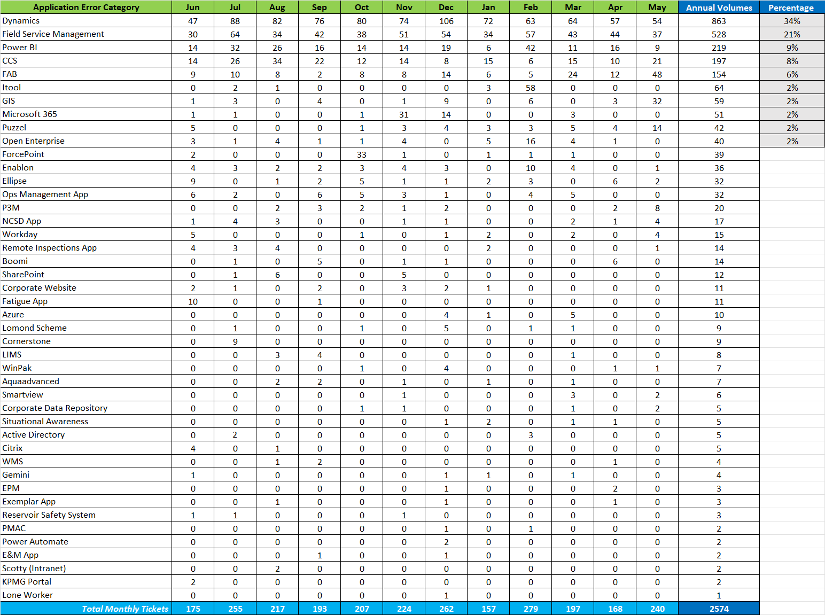

Analysis for Incidents logged in May 2025
To provide more insight into the Incidents associated with Application Errors over the last 12 months a total of 1961 or (76%) of the 2574 incidents logged annually were associated with the top 5 trending applications as outlined within the following Table 33:
Table 33
The analysis below provides insight into what are causing these incidents and opportunities for improvement:

Dynamics - 863 Annual Incidents
Throughout May 2025 - 28 (52%) of the 54 incidents were associated with stuck transactions primarily due to integration errors associated with the Boomi platform. 10 (19%) of the 54 incidents were associated with data case errors, where agents entered wrong data preventing cases to be processed correctly. In both areas there are opportunities for improvement be that the move to Microsoft’s Integration engine allowing us to retire Boomi or improved system data entry functionality to reduce the likelihood of errors.
Field Service Management - 528 Annual Incidents
Throughout May 2025 - 29 (78%) of the 37 incidents were associated with both Boomi integration failures and upload errors appearing on the salesforce-native solution, Youreka that captures online or offline data from our Field Operations. In both areas there are opportunities for improvement be that the move to Microsoft’s Integration engine allowing us to retire Boomi or the move to the new more reliable Salesforces Date Capture platform.
Power BI - 219 Annual Incidents
Throughout May 2025 - 9 (100%) of the 9 incidents were associated with Pipeline failures. In this area the opportunity for improvement is to integrate our Power BI deployment pipelines with Azure DevOps to automate the deployment process. Azure DevOps will help manage pipeline stages, deploy content, and handle failures automatically.
CCS - 197 Annual Incidents
Throughout May 2025 - 10 (48%) of 21 incidents were associated with reporting defects due to duplicate data entries as there are no distinct keywords designed into the logic of the reports being generated. 4 (19%) of the 21 incidents were associated with both Boomi integration failures. In both areas there are opportunities for improvement be that improving the code logic when developing reports and move to Microsoft’s Integration engine allowing us to retire Boomi

FAB - 154 Annual Incidents
Throughout May 2025 - 32 (67%) of the 48 incidents were associated with users being unable to access the platform due to a defect being introduced post the quarterly release. Other incidents refer to discrepancies with purchase orders due to manual data entry errors. Although Boomi integration failures are recorded as small re customer incidents associated with FAB our incumbent service provider is manually retriggering integrations every day on a proactive basis (on average 80 incidents a month). FAB is a stable system with the opportunity for improvements being the move to Microsoft’s Integration engine allowing us to retire Boomi.
  - Application Overview
The following information provides further insights into the core Enterprise Applications that are in scope of LOT 2:
Aquadvanced - Hosting environment: IAAS - SaaS

Business Function (Number of active users: 25)
Aquadvanced Water Supply by Suez ensures high-quality water is delivered where it is needed at minimum cost by optimising energy and pump usage across your distribution network. This real-time management system is proven to bring down energy costs while maximising operational performance and water quality. With higher energy efficiency you will also reduce the environmental footprint of your network.
The software uses data collected from the production-distribution system, calculating water consumption forecasts and energy prices to model the information. Aquadvanced Water Supply then defines optimised pumping strategies that are implemented automatically.
It uses SCADA and telemetry systems to read live data and issue commands to pumps and valves throughout an entire distribution system, producing the correct volume of water where and when it is needed.
Technology Stack
- A Microsoft windows 2022 server resides within Azure cloud to run the main Aquadvanced Water Supply by Suez application that resides within AWS.
- A managed SQL instance resides within Azure cloud rather than a traditional server instance. This SaaS approach minimises the administration burden while also enabling improved resilience at a lower cost.
- Connection to the Emerson OE SCADA is via intermediary server running KepserverEX and a copy of OE server & client

Maintenance Activities
- Standard maintenance and backup jobs are configured by the vendor SUEZ
- Monthly patches when required on IAAS
- Compliance requirements: GDPR, ISO27001 (Data sensitivity classification: High - no personal information)
- Authentication methods: Microsoft Entra ID

In relation to known technical debt or backlog. There is none currently as the Application is still to go through formal Acceptance into Service.

Known Issues & Risks
There is none currently as the Application is still to go through formal Acceptance into Service.

Oracle EPM (Enterprise Performance Management) - Hosting environment: SaaS
Business Function (Number of active users: 50)
Oracle EPM supports Scottish Water's financial budgeting, forecasting, and reporting against actual costs, including workforce planning. The key departments or teams using the application are the Finance Team, BPA Team and Finance Managers
Technology Stack
Oracle EPM primarily uses Calculation Manager and Groovy scripting for custom logic and automation. It also utilizes Essbase Calculation Scripts for defining business rules, calculations, and aggregations.
The production site is in a Slough data center; Disaster recovery: Amsterdam data center; Test environment available. Additionally, there are two Narrative Reporting environments which are currently unused.
The system integrates with Oracle Fusion (FAB) which is an API and File-Based Data Import (FBDI) from/to Fusion
Maintenance Activities
- Monthly patches when required
- Quarterly upgrades
- Compliance requirements: GDPR, ISO27001 (Data sensitivity classification: Low - no personal information)
- Authentication methods: SSO

In relation to known technical debt or backlog. There is none.
Known Issues & Risks
- Known issues with SmartView Excel templates requiring manual intervention to resolve duplicate value errors.

Oracle Fusion (FAB) - Hosting environment: SaaS
Business Function (Number of active users: 5150)
Oracle Fusion streamlines and automates financial processes, procurement, project financial accounting, and payroll, ensuring accurate reporting and compliance. The key departments or teams using the application are Finance Teams, Procurement buyers, Payroll and Accounts Payable teams, all employees (to access personal information such as payroll), direct purchasers.
Technology Stack
Programming Languages: Primarily Java (backend), SQL (database interactions), and JavaScript (for front-end extensions or customisations)
Frameworks: Oracle ADF (Application Development Framework), Oracle JET (JavaScript Extension Toolkit)
The system integrates to and from various applications and third parties including:
- Tungsten for Accounts Payable e-invoicing
- Microsoft Dynamics - Astro
- Oracle Unifier (P3M) - project creation and financial accounting
- Oracle CCS
- Non Complex Service Delivery app (NCSD) for Accounts Payable
- Workday for basic HR setup in HCM and Payroll data
- Ellipse (soon to be replaced by Maximo)
- ePay for BACS payments
- Corporate data lake for daily reporting consumed in PowerBI

The type of integration (API, batch, real-time, etc.): FAB counts for 71 integrations. These are mainly File-Based Data Import and API to Lakehouse (utilised for reporting)
Maintenance Activities
Frequency of updates or patches:
- Monthly patches when required
- Quarterly Release Schedule - 2-week window testing commencing on the 1st Friday of the month in February, May, August, November
- Legislative Change (Patch) - March
- Compliance requirements: GDPR, ISO27001 (Data sensitivity classification: High - Personal Data, Commercial Data)
- Authentication methods: SSO

In relation to known technical debt or backlog, there are 26 minor enhancements and 5 problem tickets.
Known Issues & Risks
- Boomi integration failures are impacting on our finance processes and require manual workarounds
- Lack of automation for recurring financial procedures (e.g., period-end) due to not being licensed for Oracle Integration Cloud Infrastructure

On average, 30% of FAB incidents relate to Time and Labour (How-to questions), whilst 60% are proactive automated-raised incidents following P3M-FAB Integration Failures (These incidents are not categorized as customer incidents within the volumes provided above).
The following are considered as risk factors:
- Integration Complexity
- Data Migration Issues
- User Adoption Resistance
- Customization Limitations
- Vendor Lock-in
- Licensing and Cost Overruns
- Delays in Updates or Patch Management
- Change Management Gaps
- Reporting and Analytics Limitations
- Workflow and Approval Misalignment

Oracle Utilities Customer Cloud Service (CCS) - Hosting environment: SaaS
Business Function (Number of active users: 130)
CCS is our Wholesale and Sundry Billing application. It is used to bill customers for Scottish Water services outside the Domestic Council Tax Charges, including lab work, septic tanks, standpipes, connections, permanent disconnections, wholesale licensed providers, and domestic measured customers.
Technology Stack
CCS primarily uses Groovy/Java as its programming languages against a proprietary framework.
The system integrates to and from various applications including:
- Microsoft Dynamics (Astro, Ascend & WMS), Sage Pay, PTX, Avery & Adaresec via Boomi (to be Microsoft AIS).
- FAB integrations via Oracle Integration Cloud (OIC).

It uses SharePoint as a document repository and can link to the corporate data Lakehouse for daily reporting consumed in Power BI and data archiving.
Maintenance Activities
- Monthly patches when required
- Biannual release schedule
- Compliance requirements: GDPR, ISO27001 (Data sensitivity classification: High - Personal Data, Commercial Data)
- Authentication methods: SSO

In relation to known technical debt or backlog, there are 4 minor enhancements and 1 problem ticket.
Known Issues & Risks
CCS reporting performance issues.
Boomi integration failures impacting finance processes.
Vendor owns the database, requiring support requests for changes without a set SLA.
Proactive manual checks and error management are carried out daily to ensure smooth operations.
Relationships with third-party suppliers managed by the business create gaps in support and upgrades (e.g., PTX for direct debit payments, Adaresec for bill printing).

Oracle P3M - Hosting environment: SaaS

Business Function (Number of active users: 1300)

P3M is one of Scottish Water’s largest and most critical corporate systems, serving as the single source of truth for our multi-billion-pound Capital Investment Programme. The system currently supports over 44,000 projects and is utilised by more than 1,300 users spanning multiple internal directorates and external delivery vehicles.

The P3M platform is powered by multiple integrated, cloud-based Oracle products: Primavera Unifier, Primavera P6, Business Intelligence (BI) Publisher, Primavera Gateway & Oracle Integration Cloud (OIC Shared with CCS).

This robust system underpins the efficient management, coordination, and delivery of our extensive project portfolio, enabling effective decision-making and collaboration across all stakeholders.

The Portfolio Systems Team is responsible for owning, maintaining, and enhancing the product on behalf of the business, ensuring it continues to meet the evolving needs of Scottish Water.

Technology Stack

- The P3M application suite features approximately 150 integrations across ten other systems -
- FAB, NCSD, Workday, BES, Power Platform, Ellipse (Maximo), Astro, Salesforce, Data Lakehouse and Microsoft Azure AD
- Internal Integrations: Between Primavera Unifier and Primavera P6, as well as intra Primavera Unifier integrations used to cascade data.

Please refer to the Integration Catalogue that will be supplied as part of the ITN process for details.

Maintenance Activities

- Monthly patches when required
- Fortnightly releases for enhancements and configuration changes
- Quarterly application upgrades
- Compliance requirements: GDPR, ISO27001 (Data sensitivity classification: High - Personal Data, Commercial Data)
- Authentication methods: SSO

Known Issues & Risks

- Bugs introduced by Oracle during quarterly mandatory application upgrades.
- The impact of moving from Dell Boomi to Azure Integrations will require extensive testing.
- Business change demand - It has been agreed that P3M will remain the tool of choice to support the capital programme during the next investment period (2027-2033). To align with the new SR27 enterprise model and facilitate closer collaboration with our partners, the following inbuilt processes may require varying levels of adaptation:

  - Access Controls
  - Investment Management
  - Management Information
  - Governance Controls
  - Project Management
  - Commercial Management
  - Specialist Services

- In 2025, the introduction of Copperleaf to enhance near-term and long-term investment planning will also have implications for P3M. Planned integrations between the two systems are under consideration, and the full scope of these changes has yet to be determined.

Open Enterprise - Hosting environment: Scottish Water Datacenter
Business Function (Number of active users: 220)
Open Enterprise is our main Telemetry SCADA system. The system enables the Intelligent Control Centre to monitor 4,000 operational assets, providing real-time alerts on potential treatment issues, network faults, and environmental pollution. These capabilities enable Scottish Water to take proactive measures before issues impact customers or the environment.
Technology Stack
Open Enterprise uses its own proprietary technology via Emerson. The system integrates with our Asset Inventory and Standby List applications using API, Real-time and Batch.

Maintenance Activities
- Monthly patches when required
- Biannual release schedule
- Compliance requirements: ISO27001, NIS (Data sensitivity classification: High – no personal information)
- Authentication methods: SSO

In relation to known technical debt or backlog, there are 4 problem tickets.
Known Issues & Risks

- Vendor lock-in due to protocol driver software caused by proprietary protocol use on RTU estate

Workday - Hosting environment: SaaS
Business Function (Number of active users: 4841)
Workday is our core Human Capital Management Platform, which hosts our worker data and our key HR business processes (Recruitment, Position management, Compensation, Absence Management) and Worker Data.
Workday is used by all departments across Scottish Water. All workers, service providers, and contingent workers will be created or hired in Workday, but only SW Employees will be able to access Workday for HR processes.
Workday is utilised as a primary business system across the People Directorate. The People Systems and Analytics Team are the internal administrators of the system.
Technology Stack
Workday uses its own proprietary technology via Workday. The system integrates with 28 systems in total. Please refer to the Integration Catalogue that will be supplied as part of the ITN process for details.
Maintenance Activities
- Monthly patches when required
- Biannual release schedule
- Compliance requirements: GDPR, ISO27001 (Data sensitivity classification: High - Personal Data, Commercial Data)
- Authentication methods: SSO

In relation to known technical debt or backlog, there is 1 problem ticket.
Known Issues & Risks
- Inefficient and unintuitive Workday configured business processes
- Lack of automated reporting capability
- Complex Security Model and lack of understanding of its impact
- Conversion of contingent workers to permanent without loss of their employee ID and IT logins/accesses
- Document Collection, Management, and Retention within Workday; Automation of Data Purging in Line with Retention Policy

Salesforce – Field Service Management - Hosting environment: SaaS
Business Function (Number of active users: 1231)
Salesforce Field Service (SFS) is our Field Service Management system used to schedule both reactive and planned work for our field staff and contractors. It is an integral application used across several operational and office teams.
Technology Stack
SFS uses its own proprietary technology via Salesforce. The system integrates with Microsoft Dynamics, Workday, Maximo, and NCSD via Boomi (to be Microsoft AIS). It also integrates with Youreka (to capture information from our field staff onsite), Aurora (SRWR), and Deponet (contractor system) via APIs).
It uses SharePoint as a document repository and links to our corporate data lake for daily reporting consumed in Power BI and archiving data.
It has deep links to our DOMS app and Take 5 (Power Apps developed by Scottish Water).
Please refer to the Integration Catalogue that will be supplied as part of the ITN process for details.
Maintenance Activities
- Monthly patches when required
- 3 mandatory releases a year
- Compliance requirements: GDPR, ISO27001 (Data sensitivity classification: High - Personal Data)
- Authentication methods: SSO

In relation to known technical debt or backlog, there are 34 minor enhancements and 2 problem tickets
Known Issues & Risks
- Boomi integration failures are impacting our finance processes.
- "Upload error" appearing on the field service application is stopping field staff from updating work.
- Ellipse work orders not generating FOW work on partially completed work orders.

Microsoft Dynamics - Astro - Hosting environment: SaaS
Business Function (Number of active users: 140)
Astro supports a wide range of business processes within our Developer Services customer-facing operations. Developers and house builders must work with Scottish Water in a regulated environment to establish connections to our network, Astro preforms complex case management for developer communicates to perform these regulated activities.
The system facilitates the creation and management of customer accounts through email, phone channels, and an Azure-hosted web portal. Customers such as developers, licensed providers, agents, and planning authorities can register via the Astro portal, triggering account creation and access provisioning workflows. Features include:

- Self-registration and internal provisioning of user accounts
- Assignment of security roles
- Maintenance and inactivation of accounts
- Access control governance and audit compliance

Astro also includes a mobile application available on iOS and Android. This app allows developers to submit inspections, pipe details, and photographic evidence of connections. This data integrates with Microsoft Dynamics 365 – Astro.

Astro supports the end-to-end process for water and wastewater service applications and physical connections, including:

- Submission and handling of application forms
- Handling of plumbing schematics, soil investigation reports, and fire safety approvals
- Meter installation and changes
- Final connections
- Integration with CCS for payment status updates and application progression
- Business Process Flows and Workflow Automation: Astro’s Dynamics 365 environment includes Business Process Flows (BPFs) for tasks such as:
- Task completion and case management
- Incident resolution and service request handling
- Integration with PowerApps and Canvas apps for enhanced user interaction

Technology Stack
- Microsoft Dynamics 365 Customer Engagement/Power Platform – SaaS
- Net Maui mobile app (Remote Inspections App)
- Angular JS Azure-hosted Web Application (Customer Portal)
- Astro uses Azure DevOps for deployment processes, moving configuration changes from Development & Test environments to Production.

The system integrates with Oracle CCS, Maximo (Asset Management), Salesforce (Field Service Management) and the Remote Inspections App (iOS and Android).

Please refer to the Integration Catalogue that will be supplied as part of the ITN process for details.

Maintenance Activities
- Weekly & Monthly patches when required
- Biannual release schedule
- Compliance requirements: GDPR, ISO27001 (Data sensitivity classification: High - Personal Data, Commercial Data)
- Authentication methods: SSO

In relation to known technical debt or backlog. Astro is configured and highly customized to meet internal regulated processes. There is currently 1 problem ticket.
Known Issues & Risks

- Remote Inspections App is undergoing redevelopment to ensure continued functionality and support for inspection processes. The App is transitioning from Blazor to .Net MAUI.
- Some complex business processes introduce a high level of configuration and supported customization.
- Known recurring issue of billing integration processes failing in CCS, requiring manual intervention.

Microsoft Dynamics - Ascend - Hosting environment: SaaS
Business Function (Number of active users: 400)
Ascend serves our household, wholesale, and back-office functions that support our end-to-end customer service process. It is designed to incorporate omnichannel engagement with a customer portal in Power Pages. Ascend enables efficient case management of customer journeys, defines SLAs, and supports business decisions centered around customer needs.
The application is the main CRM for Scottish Water, holding details of customers and their interactions. With daily active users averaging 400, Ascend handles 38 million API calls and manages over 1.5TB of data. It streamlines customer interactions and improves service delivery, with its data used across the business for operational decision-making.
Technology Stack
- Microsoft Dynamics 365 Customer Engagement/Power Platform – SaaS
- Customer Insights - Journeys
- Power Pages
- Azure App Service (Wrapper)
- Azure Integration Services
- Dell Boomi

The system integrates with Salesforce, Maximo, Orlo, social media, GIS Situational Awareness, CMA (External), Oracle Fusion, Reporting Platform, Boomi, Azure and SharePoint. Please refer to the Integration Catalogue that will be supplied as part of the ITN process for details.
Maintenance Activities
- Weekly & Monthly patches when required
- Biannual release schedule
- Compliance requirements: GDPR, ISO27001 (Data sensitivity classification: High - Personal Data, Commercial Data)
- Authentication methods: SSO

In relation to known technical debt or backlog. Ascend is configured and highly customized to meet internal regulated processes. There are currently 13 problem tickets.
Known Issues & Risks

- Storage Management: Large data volumes are challenging to manage effectively, limited storage remaining.
- Process Documentation: Insufficient documentation of processes hinders efficiency.
- Deployment Process: Current process has outgrown capabilities, leading to manual defects.
- Integration Issues: Particularly in wholesale transactions, causing operational disruptions.
- Complex Business Processes: Some processes require high configuration and customization.
- Known recurring issue of integration failing for Wholesale processes sending data to external systems. A project underway aims to simplify data residency by moving Wholesale asset information into Ascend and adopting Azure Integration Services.

Puzzel - Hosting environment: SaaS
Business Function (Number of active users: 140)
Puzzel is a Contact Centre as a Service (CCAS/SAAS) product used as our inbound telephony platform for the Customer Engagement Centre, Development Services, and other teams. The platform allows for softphone calls using the client application in the browser, IVR capabilities, and skill-based routing of calls to available agents. This is the primary channel for customers contacting Scottish Water about service issues.
Technology Stack
- Out-of-the-box CCaS/SaaS product.
- Puzzel SMS APIs are also used to send proactive messages from Dynamics to our customers, as well as for Business Alerts internally.
The system integrates with the Datalake and SQL BI Database via ADF pipeline for analytics.
Maintenance Activities
- Puzzel runs a bi-weekly release cycle.
- Compliance requirements: GDPR, ISO27001 (Data sensitivity classification: High - Personal Data).
- Authentication methods: Basic Authentication - Username and Password

In relation to known technical debt or backlog. There are none.
Known Issues & Risks

- User management is handled locally by each team with delegated permissions, leading to users still configured that have left or moved roles.
- Puzzel does not currently use Microsoft Entra ID for identity management/authentication.

Microsoft Azure Landing Zones - Hosting environment: Azure
Business Function (Number of active users: 400)
Scottish Water’s Enterprise-Scale Azure Platform (SWESP) serves as a foundational cloud platform aimed at enhancing operational efficiency, scalability, security and innovation. It is designed to provide product teams with a scalable and secure platform upon which digital products can be built. The platform has been constructed following Microsoft’s Well Architected Framework.
Technology Stack
- Microsoft Azure
Please refer to the Integration Catalogue that will be supplied as part of the ITN process for details.
Maintenance Activities
- Quarterly review and implementation of upstream ‘ALZ-Bicep’ changes to Microsoft’s WAF patterns - This is carried out by Scottish Water’s internal Cloud Engineering Team.
- Scottish Water performs regular releases as needed for incident fixes, new demands, and minor changes.
- Compliance requirements: GDPR, ISO27001 (Data sensitivity classification: High - Personal Data, Commercial Data).
- Authentication methods: Basic Authentication - SSO in Microsoft Entra ID

In relation to known technical debt or backlog. Technical debt managed by the internal Scottish Water Cloud Enablement Team using Azure DevOps and the backlog consists of new platform capabilities and enhancements to existing features and services.

Known Issues & Risks
- Storage Management: Large data volumes are challenging to manage effectively, limited storage remaining.
- Process Documentation: Insufficient documentation of processes hinders efficiency.
- Deployment Process: Current process has outgrown capabilities, leading to manual defects.
- Integration Issues: Particularly in wholesale transactions, causing operational disruptions.
- Complex Business Processes: Some processes require high configuration and customisation.
- Known recurring issue of integration failing for Wholesale processes sending data to external systems. A project underway aims to simplify data residency by moving Wholesale asset information into Ascend and adopting Azure Integration Services

Non-Complex Service Delivery (NCSD) - Hosting environment: Azure

Business Function (Number of active users: 1350)

NCSD (Non-Complex Service Delivery) is one of Scottish Water’s essential corporate systems, designed to streamline the process of raising and managing service needs. The system aims to deliver an "Amazon" style experience to users, allowing them to raise needs simply from a mobile device, select products or services from a standardised and carbon-efficient list, and automatically process orders that meet built-in asset management policies.

The NCSD platform supports a wide range of functionalities, including raising treatment and network needs, defining project scopes, and submitting needs for approval. It integrates seamlessly with other corporate systems to ensure that project and asset data are automatically updated, enabling informed and data-driven decisions.

The system is utilised by numerous users across various internal directorates and external partners, ensuring efficient management, coordination, and delivery of service needs.

The Portfolio Systems Team is responsible for owning, maintaining, and enhancing the NCSD application on behalf of the business, ensuring it continues to meet the evolving needs of Scottish Water.

Technology Stack

- The NCSD application suite features approximately 38 integrations across five other systems - Primavera Unifier (P3M), Ellipse (Maximo), FAB, Salesforce and Workday

Please refer to the Integration Catalogue that will be supplied as part of the ITN process for details.

Maintenance Activities

- Releases for enhancements and configuration changes as and when required
- Authentication methods: Azure AD, SSO

Known Issues & Risks

- User login bug resulting in session looping – workaround is available. (Authentication Issue)
- Lack of administration module to perform basic admin tasks meaning that the technical support must run scripts to update data that should be updated by a system administrator.
- There are key gaps in the integration and the data collection in this app associated with asset data.
- Impact of moving from Dell Boomi to Azure Integrations as will require extensive testing.
- The future of NCSD in its current form remains uncertain. While the functionality it provides to the business is essential and will continue to be required, the application itself may be rebuilt within Maximo. Until a decision is made regarding its future, enhancements to NCSD will remain limited.
- As Maximo is still in the development and testing phase, further updates will depend on the outcomes of this process.

GIS - Hosting environment: On Premise, AGOL

Business Function (Number of active users: 1700+)

GIS is used to master all underground asset data geographically, covers a broad remit of solutions within SW. There are currently 4 separate GIS related platforms:

Table 34
ESRI On Premise  - Cover GDBs, Desktop access (ArcMap and ArcPro) and Portal  - 350-400 users of Desktop  - 900-950 user of Portal | ESRI Cloud (aka AGOL)  - Organically grown over last 8 years  - 1200+ users
ESRI Managed Service  - Bespoke service for single app - SW GIS Extranet service  - Used by 1700+ external statutory undertakers and housing developers  - Supported by ESRI UK | Geofield On Premise  - Legacy system that was set up/configured in 2000s  - Two versions – ‘Standard’ and ‘Revenue Meter’  - Should be retired but some users still using, it as no replacement

Technology Stack

- Multiple integrations using Boomi, non-Boomi and manual interfaces:

Please refer to the Integration Catalogue that will be supplied as part of the ITN process for details.

Maintenance Activities

- No release schedule, has resulted in out-of-date software which is challenging to support
- Current licence agreement runs 01/04/25 to 31/03/26

Known Issues & Risks

- ESRI On Premise - initially configured in 2016/17 and no upgrade since (Enterprise v10.4.1/ArcMap v10.2.1/ArcPro v2.8.8) all versions out of date/key components unsupported – GIS Refresh Project pending but dates unknown
- GIS Data Model no longer meets business needs. Objective to update from Geometric Network (GM) to Utility Network (UN) Model
- Data quality issues need to be address and resolved before moving to new Data Model
- ESRI Cloud (aka AGOL) – need collaboration/support from IT partners, to provide robust governance and better service to wider stakeholder community
- Geofield On Premise – users need to be migrated to new solution. Formally retired from use.
- Increasing demand to use, create and maximise investment of GIS platforms, but age of On Premise solution, results in users turning to AGOL at additional cost (credits and licensing).

  - Integration Overview
Scottish Waters Integrations are designed to deliver resilient, scalable, and secure integration capabilities across Scottish Water’s technology landscape. By enabling robust data flows, streamlined system connectivity, and agile service development, this service underpins critical business processes and supports strategic digital transformation initiatives.

The partner will be responsible for managing and optimising all Azure-based integration assets, including Logic Apps, API Manager (including Developer Portal), Service Bus, Function Apps where required. These responsibilities span from pre-production support and production deployment to monitoring, incident management, and continuous improvement - ensuring integrations are high-performing, secure, compliant, and aligned with Scottish Waters Integration principles, FinOps principles and enterprise architecture standards.

The service will be delivered through strong DevOps practices, proactive monitoring, and close collaboration with Scottish Water's internal teams, third-party vendors, and key stakeholders. It will support both existing and emerging integration needs, including event-driven architectures, legacy system connectivity, and business-to-business APIs.
Integration Key Service Outcomes
- Stable and Secure Integration Landscape.
- Ensure the reliable, secure, and uninterrupted operation of all Azure-based integrations.
- Proactively monitor interface performance, throughput, latency, and failure conditions.
- Support both synchronous and asynchronous communication patterns across internal and external systems.
- Update and maintain the Integration Azure DevOps including the wiki, repositories,
pipelines and artifacts as necessary.
- Ensure full auditability, governance, and compliance with regulatory and internal
policies.
End-to-End Integration Support
- Provide Level 1, Level 2, and Level 3 support for all components within the Azure
Integration Services stack.
- Log and triage incidents through Scottish Water’s Customer Service Hub, ensuring
timely assignment, categorisation, and resolution.
- Maintain and support all integration modules in scope, delivering fixes and
enhancements as part of BAU operations.
- Ensure accuracy and completeness across all connected systems and business
processes, including reprocessing of failed transactions and interface health checks.
- Deliver production deployments using a pull-based model, in line with SW governance and change control processes.
- Support and maintain the integration-template that is used by projects to develop
integrations.
Scottish Water Digital Platforms Team - Integration Services
The Internal Scottish Water Digital Platforms Team working in partnership with the partner will:

- Support the exposure, versioning, and consumption of APIs through Azure API Manager (including the Developer Portal).
- Support the maintenance of the integration catalogue and periodically review its
accuracy.
Pre-Production Support and Project Engagement
The partner will support successful transition from project delivery to BAU operations by
engaging early and consistently in the pre-production stage:
- Code and Documentation Review: Evaluate integration solutions developed by projects prior to go-live, ensuring adherence to standards and operational readiness.
- Checklist Compliance: Review go-live readiness checklists submitted by project teams and identify any risks or gaps.
- Standards Signposting: Provide project teams with the correct templates, patterns, and guidance to ensure integration consistency and supportability.
- Knowledge Transfer: Participate in structured handovers from project teams, including walkthroughs, access to repositories, documentation reviews, and support onboarding activities.
- Ensure projects are developing adequate testing including integration, unit, regression, security and performance.
- Swift Incident and Problem Management.
- Rapidly detect, diagnose, and resolve integration issues, minimising business impact.
- Perform thorough root cause analysis and trend monitoring to prevent repeat failures.
- Maintain up-to-date technical and support documentation for all integration workflows.
Effective Change and Release Management
- Deliver changes using automated CI/CD pipelines, in line with SW governance and
change control processes.
- Conduct comprehensive testing including integration, unit, regression, security and
performance validation.
- Manage platform updates, API lifecycle changes, and schema modifications with full
impact assessment.
Governance, Compliance, and Security

- Adhere to OWASP and Scottish Water’s API security guidelines, including zero-trust
principles, HTTPS-only policies, and encrypted data transmission.
- Manage access with Microsoft Entra ID, enforce RBAC, MFA, and secure secrets via Key Vault.
- Ensure compliance with Scottish Water’s IT security and regulatory policies.
Scottish Water Digital Platforms Team - Integration Services
The internal Scottish Water Digital Platforms Team working in partnership with the partner will:
- Maintain audit trails and version control of all integration components and
configurations.
- Ensure existing integrations are kept up to date and compliant in using the latest
integration-template, upgrading the integrations as required.
Continuous Improvement and Optimisation
- Identify and implement opportunities to improve integration performance, resilience,
and cost efficiency.
- Identify areas of reusability and shared services to accelerate integration delivery.
- Leverage automation in testing, deployment, monitoring, and error handling to reduce manual effort and enhance reliability.
Collaboration and Knowledge Transfer
- Work closely with internal product and architecture teams to ensure integrations
support strategic initiatives.
- Document integration flows, dependencies, and data mappings with clear handover
processes.
- Support training and knowledge sharing to enable internal capability growth and
sustainability.
Strategic Value and Business Enablement
- Enable faster delivery of new services by reducing integration complexity and delivery lead times.
- Provide actionable insights into integration health, risk, and operational performance.
- Support business agility through scalable, modular integration architecture.
Transitional Support for Legacy Boomi Integrations
While the strategic direction is to consolidate all integrations within the Azure platform, a
number of legacy Boomi integrations may remain operational during the migration window. The partner may be required to:
- Maintain and support critical Boomi integrations that are not yet migrated due to
complexity, system readiness, or prioritisation.
- Monitor and troubleshoot Boomi workflows to ensure continued reliability and data
consistency.
This transitional support shall be time-bound and subject to regular review as part of the overall migration roadmap.

  - Service Descriptions, Roles and Responsibilities
The following Tables (35-42) describe the detailed responsibilities of the Lot 2 provider together with the Lot 1 provider and Scottish Water responsibilities required to deliver Applications Management. (R = Responsible; C = Consulted, I = Informed; A = Accountable).
Table 35
Application/Platform Management | Scottish Water | Lot 2 | Lot 1
Ensure application/platform access is secure and authorised |  | R
Monitoring & Performance - Manage, monitor and optimise application performance and availability, including daily checks/investigations, batch job status, and proactive tuning. Included at minimum for proactive alerting (using automation as default) is degraded response times, integration errors, application and platform errors, service health | C | R
Change & Release Management - Manage application change and release in compliance with modern ITIL processes, making use of automated deployments and Scottish Water change management processes, ensuring compatibility, traceability, and production readiness. | A | R
Configuration Management - Maintain, implement and report on application/platform configuration, including changes, upgrades, and compliance with configuration management processes. | C | R
Problem & Incident Management - Manage application/platform incidents and problems, including logging, resolution, root cause analysis, and continuous improvement coordination. Proactively alerting any problem areas and usability issues. | C | R
Evaluate the impact of new modules/features on existing application/platforms and performance providing recommendations to Scottish Water | C | R
Support delivery and accept handover from projects of new or enhanced products | I | R
Proactively monitor application/platforms against contracted Vendor Performance Measures and forecast and report to Scottish Water any issues and risks | I | R
Report incidents to vendors/3rd party suppliers in accordance with agreed procedures and performance measures where the incident cannot be resolved by the partner and have demonstrated process of investigation and problem solving steps. Update the internal incident tracking system with vendor updates and actions. | CI | R
Perform database backup, restore and recovery routines. Archive of application specific data as requested. | CI | R
Configure and track usage of security certificates across all applications/platforms, monitor against expiry dates and security threats and update proactively to maintain service availability. | I | R
Manage application/platform backup, disaster recovery and business continuity processes | C | R

Table 36
Tech Support (Level 2 & 3) | Scottish Water | Lot 2 | Lot 1
Manage application/platform incidents and problems, including identification, resolution, root cause analysis, and implementing preventative measures to prevent future incidents/problems. | C | R
Coordinate resolution of application/platform incidents and problems, ensuring ownership, escalation and clear communication to users in adherance to agreed performance measures. | C | R
Respond to and resolve application/platform support requests logged via the DEC, including user queries within agreed performance measures. | I | R
Maintain and update application/platform technical and operational support documentation to 100% accuracy ensuring accessiblility and document version controlled. | C | R
Proactively manage the schedule of all fixes or patches to resolve incidents or problems | C | R
Install, test, and implementation of all fixes or patches to resolve incidents or problems within agreed performance measures (inclusive of vendor, SW, third party suppliers) ensuring these comply with the change management process | C | R
Proactively identify problems, review and update First Time Fix procedures administered by the DEC, ensuring they are effective and up-to-date. | I | R
Complete all standard service requests within agreed performance measures, ensuring user satisfaction and compliance with SW policies. | I | R
Escalate and manage issues to the relevant vendor where a fix or modification is required to resolve a incident or problem. | C | R
Proactively seek out opportunities to improve efficiency making recommendations for improvements to optimise our applications/platforms processes and zero preventable incident ambitions. Review to be completed quarterly with Product Relationship Specialists/Product Owners/Cloud CoE | C | R
Ensure technical support is skilled accordingly in line with application/platform industry standards | I | R

Table 37
Application Release/Patch Management | Scottish Water | Lot 2 | Lot 1
Effectively manage releases through all application environments. | C | R
Ensure that an effective release management process is implemented and maintained to optimise new and changed applications/platforms. Focusing on automation and ALM practices with CI/CD. | C | R
Proactively track the vendor release cycle for tenant upgrades, feature upgrades and bug fixes. Work with Change Delivery Management, Product Relationship Specialists and Cloud CoE to find the appropriate delivery route, release schedule and plan | C | R
Provide impact analysis of known tenant and feature upgrades against end users and applications/platforms | C | R
Test upgrades/releases in line with Scottish Water's Test Approach (inclusive of SIT, UAT and regression testing). | C | R
Review new functionality and upgrades available as part of feature releases, and make recommendations on functionality to adopt that will benefit Scottish Water. | C | R
Proactively identify, source, and manage patches from third-party vendors to resolve issues, meet regulatory changes, improve security, and maintain ongoing supportability. | C | R
Define and execute application patch management policy and strategy | C | R
Provide software versioning reports and recommendations for patch implementation | I | R

Table 38
Application Environment Management | Scottish Water | Lot 2 | Lot 1
Adhere to SW environment management strategy and standards | A | R
Proactively highlight where provision and decommission of non-production environments can be made, actioning when approved by Scottish Water. Use automation practices as default. | C | R
Maintain environment catalogue with metadata | C | R
Integrate with SW’s environment scheduling and capacity planning processes | C | R
Maintain isolation between production and non-production environments | C | R
Manage SaaS/PaaS tenant upgrades through pre-prod environments per release plans | C | R
Provide automated replication of production environments for testing | C | R
Provide backup/restore capabilities for non-production environments | C | R
Support DR, failover, and integrated business continuity testing in non-prod | C | R
Monitor environment usage and generate monthly utilisation and cost reports | C | R
Ensure compliance with security, data protection, and audit requirements | C | R
Conduct regular reviews of environment lifecycle policies and automation effectiveness | C | R
Participate in post-implementation reviews of environment-related changes | C | R

Table 39
Application Configuration Management | Scottish Water | Lot 2 | Lot 1
Apply standard Configuration Management disciplines to all applications | C | R
Manage backup/restore services for all applications using native facilities or third party tooling so that all applications can be restored to agree RPO/RTO in the event of operational error, accidental deletion or corruption. | C | R
Manage backup/restore services for data to support restoration in the event of total and irrevocable loss of application. | C | R
Provide version control for all configuration changes made to applications to support change and release management. | C | R
Configure and maintain the integrity of authentication and access control mechanisms for all applications. Seek to enable SSO and standardised RBAC through Scottish Water strategic IAM platforms | C | R

Table 40
Application Change Delivery (ME/NDRs) | Scottish Water | Lot 2 | Lot 1
Carry out feasibility, impact analysis, estimation of effort, development and documentation of approved changes. | C | R
Support, facilitate and perform appropriate testing of approved changes using automated testing as default. | C | R
Liaise with business users/PRS/Cloud CoE to create requirements statements and manage changes in line with approval, release, and change control procedures. Ensure all requirement statements are saved as per agreed Scottish Water processes. | C | R
Liaise with Change Delivery Management, Product Relationship Specialists, Cloud CoE to confirm conflicts with any in-flight developments prior to changes. | C | R
Provide feedback and guidance on requested change requests to ensure the best solution is implemented | C | R
Ensure all changes are delivered to agreed performance measures | C | R

Table 41
Application License Management | Scottish Water | Lot 2 | Lot 1
Maintaining a record of Scottish Waters Licence entitlements for inscope applications and services | C | R
Monitor Scottish Water's utilisation of licences against entitlement | C | R
Detect and report on any issues in respect of potential license compliance risks and, where requested by Scottish Water, effect removal of non-standard, non-licensed or illegal software | C | R
Undertake monthly application license management process audits in order to: a) certify that the processes are be managed and adhered to, and b) to drive continual improvement to these license management processes | C | R
Assist Scottish Water and external parties in independent software audits (e.g. Oracle, Microsoft, IBM), and any resulting investigations | C | R
Produce quarterly status report on licensing position for agreed software installed on the Scottish estate | C | R
Produce monthly licence status report (to include: new purchases, license renewals, licenses released, potential compliance issues, potential opportunities) | C | R
Proactively maintain software vendors license monitoring and compliance tools applying upgrades, patches, metadata sets, configuration updates and software updates on a timely basis | C | R
Make proactive recommendations to manage and reduce licensing costs for Scottish Water (e.g. buying or releasing licenses, license renewals, migrating to new licensing models) | C | R

Table 42
BI/Integration/Bespoke Applications Support | Scottish Water | Lot 2 | Lot 1
Perform daily checks and monitoring on interfaces, batch jobs, workflows and bespoke applications | C | R
Identify and resolve/identify resolution to Incidents that prevent interfaces, batch jobs and bespoke applications performing as expected | C | R
Apply appropriate testing to changes prior to release to production | C | R
Provide technical assistance on the general usage of any component in the supported systems | C | R
Provide assistance in performing Problem determination, isolation and resolution | C | R
Comply with Scottish Water change management and release management processes | C | R
Provide version control management of all Integration and Bespoke Application software | C | R
Resolve unscheduled workflow issues | C | R
Promote new and amended interfaces and workflows into production environment and maintain audit trail | C | R
Provide support and advice on production interfaces and workflows | C | R
Provide fixes to bugs and defects identified in integration software | C | R
Maintain and update integration maintenance tables and coded values as requested | C | R
Provide support rovide technical support on Delta Lakehouse technologies Databricks, Fabric, Azure BI technology stack | C | R
Resolve report refresh issues | C | R
Implement data archiving policies for Integration, BI and Bespoke Application data | C | R
Provide support and advice on bespoke applications | C | R
Provide fixes to bugs and defects identified in the bespoke applications | C | R
Implement fixes and new/amended bespoke application software into production and maintain audit trail | C | R
Pro-actively identify improvements to performance of supported software | C | R
Pro-actively identify solutions to rationalise bespoke application usage | C | R
Provide database management, maintenance & monitoring for all integration, BI and bespoke application environments | C | R
Identify potential problem areas and bottlenecks and alert Scottish Water and appropriate service delivery partners | C | R
Ensure delivery of integration, BI and bespoke application software is in line with standards and policies and meets the production acceptance criteria | C | R
Identify & implement opportunities to improve cost efficiency and improve resilience | C | R
  - Product Relationship Specialist Team
A key internal Scottish Water function that LOT 2 will engage and work with on a day-to-day basis is our Product Relationship Specialist Team.
The Product Relationship Specialist (PRS) function plays a key role in bridging the gap between business needs and the digital products that support them. They ensure that Scottish Water fully leverages product capabilities by helping users understand how to use the products effectively and by promoting self-help resources that reduce common support queries. Acting as the voice of the business products, the PRS identifies opportunities for product improvement and growth by staying informed about new features, industry trends, and feedback from other users.
In addition to managing and prioritising product backlogs and new demands, the PRS carefully balances the risks and benefits of customising products versus using standard, out-of-the-box functionalities. This ensures that business processes are supported by the best digital solutions available. The PRS also advises on the technical design and approach to product changes, providing guidance to projects involving product components to help ensure smooth integration and successful delivery.
Maintaining product stability is a vital responsibility; the PRS works closely with digital partners and vendors to ensure system health, prevent disruptions, and ensure reliable performance. When incidents occur, they lead root cause analysis efforts, collaborating with partners, vendors, and business units to reduce the recurrence of preventable issues. This problem management focus drives continuous improvement and minimises operational risks.
The PRS owns, or works with business Product Owners, for the product vision and roadmap, aligning it with strategic business goals. They engage with stakeholders to gather requirements, manage expectations, and communicate progress transparently. By fostering strong relationships across the business and technical teams, the PRS ensures that product development and enhancements deliver real value and support Scottish Waters priorities.

  - Product Relationship Specialist - Requirements
Service Descriptions and Roles and Responsibilities
The following Table 43 describes the detailed responsibilities of the Lot 2 provider together with the Lot 1 provider and Scottish Water responsibilities required to deliver the PRS function. (R = Responsible; C = Consulted, I = Informed; A = Accountable).
Table 43
Product Relationship Specialist (PRS) | Scottish Water | Lot 2 | Lot 1
Own and work with business Product Owners, for the product vision and roadmap, aligning it with strategic business goals | A/R | I | I
Work with the Product owners to ensure they are fully leveraging product capabilities and new features | A/R | I | I
Manage and prioritise product backlogs and new demands | A/R | I | I
Own the Product Release Schedule for all products including all Direct to Vendor products and publish to the delivery Partner | A/R | C | C
Own the communication schedule for all mandatory releases aiding the delivery Partner through their release processes | A/R | C | C
Promote self-help resources that reduce common support queries into the DEC where their products are relevant | A/R | C | C
Identify opportunities for product improvement and growth | A/R | C | C
Review the risks and benefits of customising products versus using standard, out-of-the-box functionalities | A/R | C | C
Own the Product Documentation Repository ensuring all relevant product life-cycle documentation is maintained and up to date (This includes all Direct to Vendor documentation) | A/R | C | C
Contribute to Problem Management & Major Incident Management forums where their products are relevant | R | C | C
Contribute to all JSR, DCEM and Knowledge Management forums | R | C | C
Contribute to building strong business contextualisation across the Partnership where their products are relevant | R | C | C
Contribute to Acceptance into Service processes for new and or changed products | R | C | C
Contribute to Change Management approvals where their products are relevant | R | C | C
Own the bi monthly Centre of Excellence (COE) engagements bringing together the Product Owners, Partners and Vendors to address challenges and promote needs | A/R | C | C
Provide guidance to projects involving product changes and or enhancements to ensure zero business disruption | A/R | C | C
  - Digital Platform Team
A key internal Scottish Water function that LOT 2 will engage and work with on a day-to-day basis is our Digital Platforms Team, a strategic internal function responsible for the design, build, and continuous improvement of our core digital technology platforms.
Role of the Digital Platforms Team
The Digital Platforms function is accountable for enabling secure, scalable, and efficient digital services across Scottish Water. It provides the foundational platforms and tools that support application hosting, integration, automation, and emerging technology adoption.
The team operates across five core domains:
Cloud Platform Management
Ownership of Scottish Water’s Microsoft Azure environment, including:

  - Resource provisioning and infrastructure-as-code (IaC) using Bicep
  - CI/CD pipelines through Azure DevOps
  - Monitoring, governance, and policy compliance
  - Cost management and platform resilience
  - Azure Landing Zone configuration and evolution

Integration Services
Design and management of API-led and event-driven architectures, with key technologies including:

  - Azure API Management
  - Azure Logic Apps
  - Azure Functions
  - Azure Event Grid and Service Bus (where applicable)

Automation & Robotic Process Automation (RPA)
Delivery of cross-platform automation using:

  - Microsoft Power Automate (cloud and desktop flows)
  - Azure automation services
  - Integration with enterprise applications and data sources

Low-code, No-code & Pro-code Development Enablement
Supporting a federated development model:

  - Providing secure, well-governed environments for Power Platform (Power Apps, Power Pages, Dataverse)
  - Setting guardrails, development standards, and support models
  - Enabling effective handoffs between business users and IT professionals

Innovation Enablement
Creating space for safe experimentation and early adoption of emerging technologies, such as:

  - Microsoft 365 Copilot
  - AI/ML-backed automation
  - New capabilities across Azure and the wider Microsoft ecosystem

The Digital Platforms team works closely with internal architecture, cybersecurity, product, and delivery teams to ensure all platforms are robust, strategically aligned, and cost-effective.
Expectations for the Supplier
Suppliers responding to Lot 2 are expected to collaborate effectively with the Digital Platforms Team across the following dimensions:
- Operational Support & Monitoring
Provide 24x7 operational support for the Azure platform, including incident response, monitoring, and health checks. Work alongside the Digital Platforms team to ensure timely escalations and resolution of issues affecting platform availability, cost, or performance.

- Governance Alignment
Enforce platform governance policies defined by the internal team. This includes resource tagging, policy compliance (e.g., Azure Policy, RBAC), and alignment with our FinOps practices. Bidders should describe how they will maintain alignment with Scottish Water’s platform standards and compliance requirements.

- Infrastructure Deployment & Optimisation
Support the design and deployment of Azure resources using Bicep and automated pipelines. Suppliers should demonstrate expertise in DevOps practices and describe how they will work with internal DevOps leads on shared CI/CD workflows, environment provisioning, and quality controls.

- Cost Management
Assist with Azure cost optimisation, budget alerting, and usage reporting. While strategic cost accountability remains with the internal team, suppliers should describe their capabilities in detecting anomalies, proposing savings opportunities, and integrating with Scottish Water’s FinOps tooling and practices.

- Innovation Support
Engage with the internal team during proofs of concept and pilots involving new Azure or M365 capabilities (e.g. Copilot Studio). Bidders should outline how they will contribute to the rapid evaluation, safe experimentation, and transition of successful pilots to supported services.

- Toolchain Interoperability
The internal team maintains and governs the toolchains used across Azure and Power Platform. Suppliers must demonstrate ability to work within existing tools and pipelines (e.g., Azure DevOps, GitHub, Intune, Azure Monitor, SonarQube, Postman, Jmeter) without introducing unnecessary duplication or fragmentation.
  - Digital Platforms Team- Requirements
Service Descriptions and Roles and Responsibilities
The following Table 44 describes the detailed responsibilities of the Lot 2 provider together with the Lot 1 provider and Scottish Water responsibilities required to deliver the Digital Platforms Team function. (R = Responsible; C = Consulted, I = Informed; A = Accountable).
Table 44
Digital Platforms Team | Scottish Water | Lot 2 | Lot 1
Azure resource provisioning (via IaC / Bicep) | R | A/C
CI/CD pipeline design (Azure DevOps) | A/R | C
Azure landing zone governance & design | A/R | C
Day-to-day Azure monitoring & alerting | C | A/R
Incident management | C | A/R
Azure cost optimisation & anomaly detection | A/R | C/I
Platform policy enforcement (tagging, RBAC, etc.) | A/R | R/C
Change management for Azure infrastructure | A/R | C
FinOps tools integration & usage reporting | A/R | C
Innovation proof-of-concepts (AI, Copilot, etc.) | A/R | C
Documentation & runbooks for Azure components | A/R | R
Note: The partner must clearly articulate:
- How they will interface with Scottish Water’s Digital Platforms Team on a day-to-day basis.
- How will handoffs be managed between supplier-provided 24x7 services and in-hours internal teams.
- Their approach to ensuring policy compliance, platform governance, and cost efficiency.
- Any value-added capabilities they can bring to complement our innovation and DevOps objectives.
- Experience operating within a federated support model, where internal and external roles are clearly defined, but collaboration is essential.

  - Device Management Services
A key internal Scottish Water function that LOT 2 will engage and work with on a day-to-day basis is our Device Management Team.
The Device Management Team will oversee the deployment, maintenance and support of Scottish Water’s devices such as Laptops, Tablets, Mobile Phones and all relevant peripherals.
The function covers six key domains:
- Provisioning and Deployment: Setting up new devices and ensuring they are configured correctly. This includes application packaging, preparing and deploying applications to devices managed by Microsoft Intune.
- Maintenance and Updates: Keeping devices up to date with the latest software and security patches via Microsoft Intune mobile device management (MDM) tools.
- Support and Troubleshooting: Assisting users with device-related issues and resolving technical problems at a local onsite level.
- Inventory Management: Tracking and managing the inventory of devices to ensure efficient use and replacement. This includes License Management for all desktop products.
- Life Cycle Management: Initiating and managing the Hardware Warranty Repair for devices that are covered under a manufacturer's warranty and managing the disposal of end-of-life devices.
- Security Management: Implementing security measures to protect devices from unauthorised access and threats.

The Device Management function provides a fixed (x2) and mobile (x4) Tech Bar for customers to walk up and receive 1-2-1 support. They also maintain our click and collect offerings across 27 Scottish Water locations, so customers have speedy access to replacement equipment.
This function also provides a click and courier function for customers working from home, allowing them to request equipment that will be shipped directly to their location of choice.
As with our current service we expect the Digital Experience Center to remedy most device issues reported to them via the use of the Microsoft Intune Remote Help tool, also leveraging the advanced analytics capabilities of Microsoft and NexThink tooling to trouble shoot and preform remedial actions.
The Device Management Team will work closely with the Digital Experience Cente to ensure knowledge is always valid and up to date with any changes that will occur with the device estate.
Within Intune Support Services, we are looking to secure a partner who can offer 24/7 support for our Application Estate - Azure, specifically for Microsoft Intune, on a call-off basis. This support will complement our internal Device Management team, who are certified Intune technicians with access to the Microsoft Intune Admin Center.
These support services should be available on a call-off basis, allowing us to utilise support hours as needed without a fixed monthly commitment and deliver certified Intune experts capable of handling complex issues that our internal team may escalate.
The partner will work seamlessly with our internal Device Management team, providing additional support and expertise as required.

  - Device Management Services- Requirements
Service Descriptions and Roles and Responsibilities
The following Table 45 describes the detailed responsibilities of the Lot 2 provider together with the Lot 1 provider and Scottish Water responsibilities required to deliver the Device Management Service. (R = Responsible; C = Consulted, I = Informed; A = Accountable).
Table 45
Device Management | Scottish Water | Lot 2 | Lot 1
Provisioning and Deployment: Setting up new devices and ensuring they are configured correctly. This includes application packaging, preparing and deploying applications to devices managed by Microsoft Intune | A/R | I | I
Maintenance and Updates: Keeping devices up to date with the latest software and security patches via Microsoft Intune mobile device management (MDM) tools. | A/R | I | I
Tech Bar - Deliver a fixed and Roaming Tech Bar function that provides expert advice and guidance to users with device-related issues and resolving technical problems at a local onsite level. | A/R | I | I
Leverage Intune Support Services for complex technical issues from the partner that is available 24/7 on a "call-off basis". | A | R | I
Inventory Management: Tracking and managing the inventory of devices to ensure efficient use and replacement. This includes License Management for all desktop products. | A/R | I | I
Life Cycle Management: Initiating and managing the Hardware Warranty Repair for devices that are covered under a manufacturer's warranty and managing the disposal of end-of-life devices. | A/R | I | I
Security Management: Implementing security measures to protect devices from unauthorised access and threats. | A/R | I | I
Click and Collect - Maintain all Click and Collect service offerings ensuring sufficient stock is always available to service demand. | A/R | I | I
Click & Courier - Provide distribution service for Click and Courier requests ensuring sufficient stock is always available to service demand. | A/R | I | I
Knowledge Share - Ensure the Digital Experience Centre is continuously kept up to date with device changes and supporting knowledge articles | A/R | C | I
Procurement - Procure all stock from agreed supply chain | A/R | I | I
Meeting Room Tech - Act as the first point of contact for meting room tech issues and or advice | A/R | I | I
Develop Device Refresh Roadmap and keep it updated for all devices | A/R | I | I
Manage and support larger device refresh initiatives | A/R | I | I

Business Analytics Services
A key internal Scottish Water function that LOT 2 will engage and work with on a day-to-day basis is our Business Analytics Team.
The Business Analytics Team leverages digital technologies, data, and advanced analytics to transform decision-making across the organisation. They are focused on delivering high-quality data and analytics products via the Cloud Data Platform.
- Data products are optimised for reporting, dashboards, and business insights, and can be accessed directly by business users or delivered through the team’s support model.
- Analytics & ML/AI-driven products convert data into actionable insights, enabling informed decisions across operational, tactical, and strategic levels.
- Dashboards and visualisations help users understand data quickly, monitor key metrics, and act on data-driven insights.

The team is responsible for the management and development of the Cloud Data Platform, which supports data storage, integration, and governance. This platform provides a robust foundation for analytics activities, including ML and AI. Key responsibilities include data ingestion and integration, data cleansing and rationalisation, and technical design assurance.
The team consists of specialists in data science, data engineering, software development, and solution architecture. They collaborate to deliver value through digital technology, using statistical methods, data science, and ML/AI to forecast trends, anticipate business needs, and develop descriptive, predictive, and prescriptive solutions. The team operates within an agile framework to ensure products are adaptable and aligned with user needs.
Figure 3 below outlines service areas categories.
Figure 3
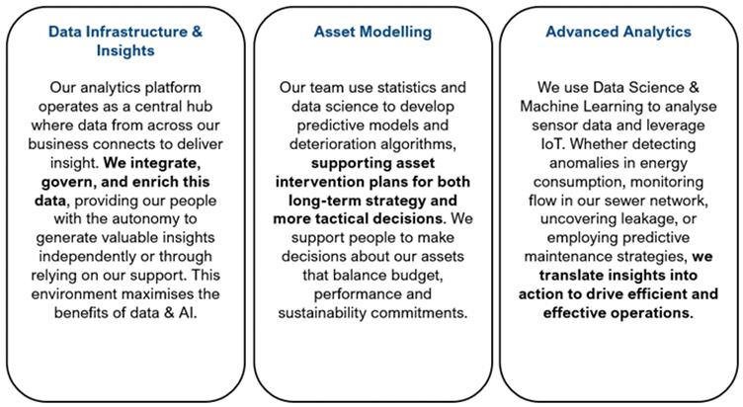
Core technologies include (but not restricted to): Lakehouse (Delta lake), Databricks, Fabric, CI/CD pipelines, Azure BI technology stack, streaming Analytics, MLflow.
The team operates under DevOps principles and often delivers value within wider product teams. It collaborates closely with architecture and cyber security, the Digital Platforms Function, and the Corporate Data and Compliance Function.
  - Corporate Data & Compliance
A key internal Scottish Water function that LOT 2 will engage and work with on a day-to-day basis is our Corporate Date & Compliance Team.
Data Advancement Centre of Excellence
In-house teams that advance the data position, through implementing data and geospatial solutions that deliver progress against the 5 data health measures. (reducing privacy risk, growing data value through making it work harder for us, improving data quality, enabling capacity through an increase in productivity when working with data, all contributing to an improved data culture).
The in-house team however do not operate in isolation and it created the Data Gateway for our business to identify what was valuable to them now, or where data was getting in the way for them now, and all opportunities are assessed and prioritised based on impact on our data position (health measures), value (making our data work harder for our business) and capacity creation (reducing content and creating capacity).
This collaborative approach ensures the in-house team focusses on what the business places most value against. This is not a ‘demand service’ but a collaborative approach to ensure we focus data efforts where it matters most and where it is most valuable. By using Scottish Water expertise, with Scottish Water knowledge and banking that knowledge for the future allows for fast delivery of valuable data solutions.
We see on average 250 Data Gateway opportunities per annum. From evaluation of these we take forward those that bring the best value to Scottish Water whilst progressing our data health measures. We average 50 solutions per annum across data journeys, information flows and geospatial innovations. The technologies we have in place allow us to quickly develop data solutions, re-use previous approaches rather than recreate, through using data-focused expert resources in the centre of excellence. If a solution is business critical it is handed into service to the partner as they have the required 24/7 support when needed. In the main our solutions do not require support as they are self-managed by end users.
The teams also manage the day-to-day asset information model (SharePoint, Ellipse & GIS), asset surveys, quality improvement and operating manuals models. The teams also manage the data model & mapping alongside the system administration of GIS including licensing analysis. The teams act as product owners for M365 (SharePoint, Engage, OneDrive, Information Management) and GIS.
The teams will engage with the partner who provide support for Microsoft (information & data) and Application Support (system administration) for technical support of GIS. The partner will provide minor enhancement days that we may utilise if technical change is required, eg integration change for GIS, Auto batching scripts.
Data Design Centre of Excellence
In-house teams provide data design and readiness (data architecture) to projects within the Transformation and Digital Portfolios and an independent focus on asset data models and quality improvement, in support of sustainable investment decision making. This enables a more efficient approach to data design for portfolios of change, whilst being a more effective use of resources, as one designer can serve multiple projects at any one time.
The new portfolio led in-house approach removed delays to onboard green resources and was more adaptable than commercial arrangements, bringing Scottish Water knowledge into projects and banking that knowledge for the future at the end of the project.
The pull for these portfolio services sees us active across c30 projects pa. Future demand analysis sees per annum projects to remain at c30 pa, which is conservative as the expectation as we transform, and harness AI will see these portfolios grow. The teams are the owners of our corporate data model and catalogue products. They provide the standards for data architecture. The teams act as product owners of Microsoft Purview. The teams will engage with the partner if they are engaged in Projects, and in some instances the partner will provide data architecture, where there is not enough capacity in the in-house team. The teams will engage with the partner in relation to Purview support (once implemented).
Data Adoption Centre of Excellence
To improve data management, remove data challenges and harness the value locked in our data assets, in a way that is legal, fair and ethical can only be met if we support our people to become increasingly data, AI and privacy fluent. Evidence and research show a direct corelation between poor data fluency and inaccurate decision making, decreased productivity, lack of innovation, poor customer experience, poor performance, poor employee experience.
Data is pervasive in every single role, from collection, to use, to re-use, to insights and decision making. Growing a corporate understanding of the importance of this, and the consequence if it goes wrong is vital.
We have an in-house adoption centre of excellence to meet this need. We also launched Data Citizenship and support it to thrive. The Data Citizenship is the vehicle to make a change in mindset for all our people, supporting them to increase their confidence when working with or talking about data, better understand the impact they can have on data quality, more likely to use data in their decision making and more confident in self-serving data from creation to analysis.
The increased levels of change and complexity at Scottish Water also require continual engagement to ensure appropriate organisational measures for compliance. It is important to learn from mistakes, incidents, and breaches. Organisational measures are essential in protecting Scottish Water from data breaches.
These measures provide vital evidence when facing regulatory or other challenges and play a crucial role in preventing repeat incidents or poor practices. These measures are continuously tested to ensure compliance and serving as evidence in investigations and challenges related to data breaches and ICO reporting. Many ICO reprimands and fines have resulted from insufficient organisational measure evidence, highlighting the connection between privacy compliance, data breaches, and how individuals are supported.
Data Compliance Centre of Excellence
Regulations & Regulators: Public Records Scotland Act, INSPIRE regulations, Re-Use of Public Sector Information, Information Commissioner UK, DPA UK & GDPR UK, Scottish Information Commissioner, Re-use of Public Information Act, WICS, DWQR, SEPA, ICG, Scot Government, Consumer Scotland.
Innovation and Research: Stay updated with the latest research, legislative changes and innovations in AI, Privacy, Protection, and Identity to continuously improve practices.
The in-house teams are a compliance centre of excellence that monitors, reviews, translates impact, develops & implements policy or other changes in relation to the wide-ranging regulations in the data and information arena. They are accountable for the technical and organisational measures to ensure corporate compliance in relation to data and information.
The teams ensure we meet our obligations and understand the impacts of all change in relation to privacy, protection and data, developing and maintaining our principles, policies and standards, including privacy, ethics, identity management, internal and external audit and access to information in the support of corporate investigations.
The teams are the owners of identity management and set the standards, policies and data driven rulesets to manage our joiners, movers, leavers authentication and access rights. They also set the standards for access provisioning in the various digital solutions, and retain provisioning for our highest risk areas, such as HR and Finance. The teams delegate the access provisioning for most of our solutions to the partners, PRSs or Scottish Water business systems teams, or Scottish Water people directly.
The teams provide records management and business classification and retention maintenance alongside sensitivity labelling and data loss prevention maintenance. The teams define the standards, policy and processes for information management. Together they provide the day-to-day Information Office, Identity Office and Privacy Office at Scottish Water which includes the management of data incidents, breach investigations, risk identification and mitigation.
The teams act as the product owners for the privacy management system, information management systems, the identity governance suite and the M365 administration and audit products. The teams will engage with the partner in relation to support as needed to support investigation and fact-finding. This partner will also provide a range of reporting & alert system administration for us.

- Service Measures - Service Level Requirements

Scottish Water designed these measures to be:
- Practical: Metrics that can be realistically measured.
- Valuable: Metrics that provide visible benefits to the business in terms of outcomes.
- Constructive: Metrics that help drive the right behaviors for all parties involved.
- Flexible: Metrics and credits that can be regularly adjusted.

Business Outcomes
Importantly, the Digital Success Measures in 2026 will be directly mapped into our business performance measures and reporting areas so we can demonstrate how we contribute towards the overall performance and success of our Business.

Scottish Water's business success measures are designed to help our organisation understand where improvements and changes can be made to continue providing great value and service excellence to customers and communities across Scotland. These measures, shown in figure 4, also support the company's people and our drive towards net zero.
Figure 4
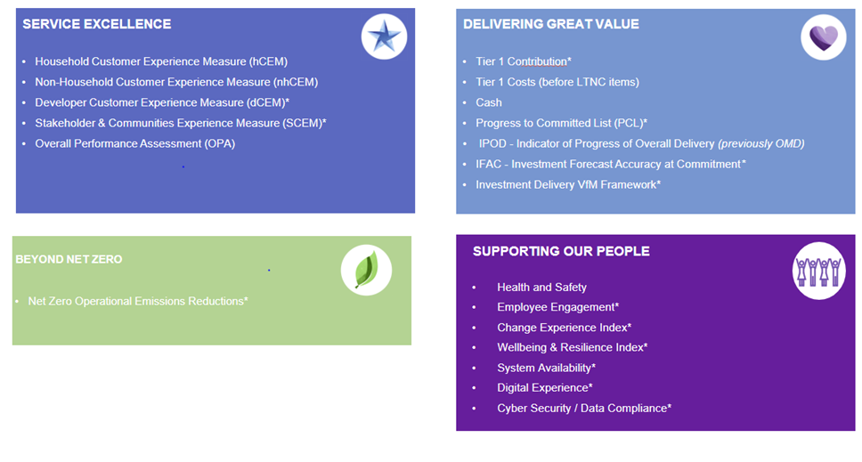

Introducing Service Level Objectives (SLOs) is a strategic move that will significantly enhance the effectiveness of Scottish Water's service delivery. While traditional Service Level Agreements (SLAs) and Key Performance Indicators (KPIs) are essential for ensuring that external services meet the required standards and issues are remedied promptly, SLOs provide a more purposeful and outcome-focused approach.

Key Points about the Scottish Water Digital Service Level Objectives (SLOs):

- Purposeful Measures: SLOs are designed to go beyond the basic requirements of SLAs by focusing on the availability and performance of critical digitally enabled business process journeys. This ensures that the services provided are not only meeting the minimum standards but are also aligned with the strategic goals of Scottish Water.

- Support for Business Success Measures: The SLOs are crafted to support Scottish Water's business success measures, which include service excellence, delivering great value, and driving towards net zero. By aligning SLOs with these strategic ambitions, Scottish Water can ensure that its digital services contribute directly to the overall success of the organization.

- Focus on Availability: One of the primary aspects of SLOs is the availability of critical business processes. This means that the performance and uptime of these processes are continuously monitored and optimized to ensure they are always available when needed, thereby minimizing disruptions and enhancing customer satisfaction.

Through the adoption and achievement of the service measures the 2026 our Digital Partnership and internal delivery functions will outperform against their key outcomes:
- (SW) SIAM - Seamless and Integrated enhanced performance of the end-to-end IT delivery model, maximising knowledge and the use of industrialised processes across the ecosystem, adopting leading proactive service operations disciplines and increasing the maturity of the Digital Directorate service operations capability.

- (Lot 2) Digital Experience Centre - Maintain as a minimum current levels of customer satisfaction in parallel to enhancing service quality and satisfaction using intelligent, personalised digital channels to increase outbound proactive engagements ensuring our DCEM is above 94%.

- (Lot 2) Applications Management - Proactive maintenance and availability of the application estate with minimal interruptions and high availability, exploit existing applications and opportunities to reduce lifetime costs and increase quality of new services released into the business.

- (Lot 1) Network & Security - Ensures robust performance, security, and reliability of the network and cyber infrastructure with minimal network interruptions and high availability. Achieving the goal of zero cyber incidents.

- (SW) Digital Workplace Service - Enhance the overall employee experience, improve productivity, and ensure seamless operations for the consumption of technology devices.

- (All) Managing Change - Reduction in the change implementation lifecycle timescales, increasing speed of delivery, from design to operations, with improved quality controls and alignment to a single Change Delivery program for all IT change.

Incident Management
Incident Response and Resolution Targets
The Service Levels that the partners of all lots are required to achieve for the Services are set out in the Table 46 below:

Table 46
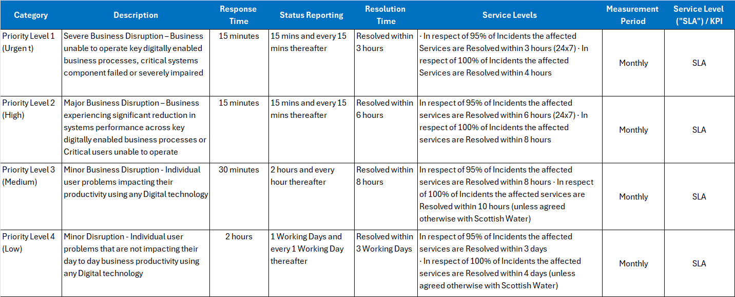
Response Time

- The maximum time for the appropriate Resolver Group to evidence and acknowledge the commencement of addressing the incident or request.

Measurement Start Point

- When the Call is assigned to the partner by the Digital Experience Centre and the Supplier receives notification of such assignment.
- If, when the partner logs an Incident with the Digital Experience Centre for Incidents that the partner becomes aware of through the performance of its obligations under the Agreement, the partner must log such Incidents immediately upon becoming aware of them.

Resolution Time

- The maximum time before a temporary or permanent Resolution is applied to alleviate the Problem and restore service.

Measurement Start Point

- When the Call is assigned to the partner by the Digital Experience Centre and the partner receives notification of such assignment.
- If, when the partner logs an Incident with the Digital Experience Centre for Incidents that the partner becomes aware of through the performance of its obligations under the Agreement, the partner must log such Incidents immediately upon becoming aware of them.

First Time Fix Measurements

Incidents and Requests which require little elapsed time to resolve such as Password Resets will be logged as a P5. These calls in nature are resolvable almost instantly. Therefore, the response and resolution time will be set as a maximum of 30 mins.

As technology and automation advances, the possibilities of more categories of incidents and responses which can be resolved with this speed is expected to increase. Therefore, these categories will be continually reviewed.

Zero Preventable Incidents

Scottish Water is looking for partners who focus on preventing incidents rather than just fixing them. This proactive approach involves regular inspections, servicing, and repairs of systems and assets to prevent unexpected failures and extend their useful life. By addressing potential issues before they become significant problems, this type of maintenance reduces downtime and improves reliability.

Additionally, effective IT change management processes are crucial. These processes ensure clear communication, prevent service interruptions, and maintain user trust during changes. When implemented effectively, IT change management not only mitigates risks but also drives innovation.

The Service Levels that the partners of all lots are required to achieve for the Services are set out in the Table 47 below:

Table 47
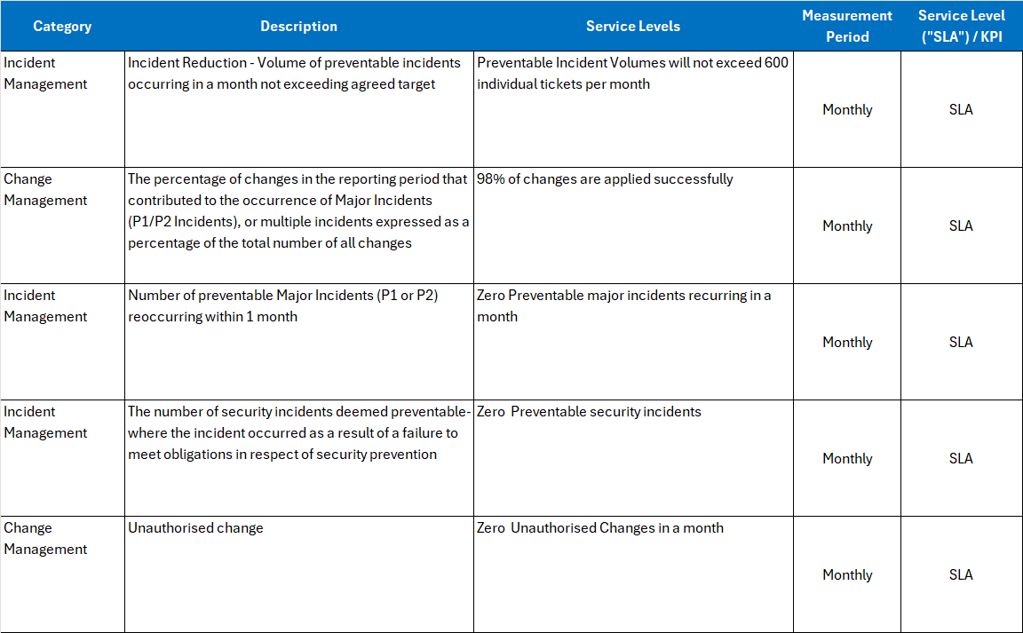

A preventable IT incident refers to an incident that could have been avoided if reasonable measures had been taken. This involves proactive maintenance, monitoring, and adherence to best practices to identify and address potential issues before they escalate into significant problems.

Definition:

- Proactive Measures: Preventable incidents are those where the responsible party failed to take reasonable steps to prevent the incident from occurring. This includes regular inspections, servicing, and repairs of systems and assets. Failure to bring market expertise and knowledge to the table would be considered a failure in proactive measures.

- Accountability: In the context of Scottish Water, a preventable incident is one where the partner failed to take reasonable measures to prevent the incident from occurring and recurring. The partner is held accountable for these preventable incidents.

- Examples of preventable incidents might include failing to apply necessary patches, not performing regular system checks, ignoring warning signs that could have indicated an impending issue, or applying poor controls during technical change. Additionally, failing to contribute to Knowledge Management by not providing end users and other resolver teams with intuitive instructions and resources for self-service can lead to unnecessary incident reports. Effective knowledge management will help our users resolve common issues on their own.

- Provide technical insight & expertise when reviewing Incidents, problems, errors and requests. Scottish Water expects the partner to lead the conversation on trends, provide potential solutions, and continually work towards the Zero Preventable Incident culture.

Examples of current Incident categories and associated volumes classified as preventable are set out in the Table 48 below.

Table 48
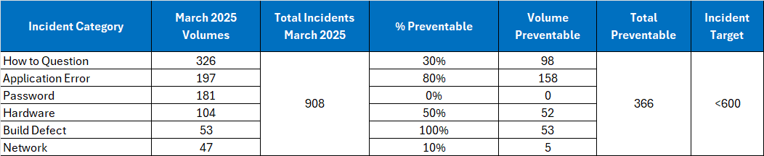

Based on current information available, here is an insightful overview of the various incident categories:

How to Question

- Definition: These are inquiries from users seeking guidance or instructions on how to perform specific tasks or use certain features. They often involve questions about software usage, system navigation, or procedural steps.
- Example: Questions related to Windows 10 and email account for a significant portion of these inquiries

Application Error

- Definition: These incidents occur when an application fails to function as expected due to bugs, glitches, or other issues within the software.
- Example: Dynamics Errors and Field Service Management errors are common types of application errors.

Password Change

- Definition: Requests or incidents related to changing or resetting user passwords. This can include forgotten passwords, expired passwords, or security-related password updates.
- Example: Password reset requests are common and often involve systems access.

Hardware Fault

- Definition: These incidents involve physical issues with computer hardware or peripheral devices. This can include malfunctions, damage, or failures of hardware components.
- Example: Common hardware faults include issues with Windows 10 laptops and mobile phones.

Build Defect

- Definition: These are faults or issues that arise during the build or deployment of software or hardware. They are typically identified during testing and need to be addressed before the final release.
- Example: Windows 10 laptop defects account for the majority of build defects.

Network Fault

- Definition: These incidents involve failures or issues within the network infrastructure. This can include connectivity problems, communication protocol failures, or issues with network hardware.
- Example: PSTN (BT Line Faults) and broadband faults are common types of network faults.

General Incident Management Measures

MIR (Major Incident Report)

The Major Incident Report (MIR) is a detailed document that outlines the specifics of a major incident, including its impact, resolution, and lessons learned. The following are required components that the supplier will provide post a major incident:

- Incident Reference Number: The unique ServiceNow identifier for the incident.
- Priority Level: The severity of the incident, such as P1 (Priority 1) or P2 (Priority 2).
- Incident Summary: A brief description of the incident, including the affected services and the impact on the business.
- Recommendations and Actions: Details of the actions taken to resolve the incident and any recommendations for preventing future occurrences.
- Lessons Learned: Insights and ideas for improvement based on the incident.
- Metrics: Evaluation of the response to the incident, including timeliness, accuracy, and effectiveness of communications.

Problem Management
Where an incident occurs and gets resolved but then it reoccurs and the underlying cause for this recurrence is unclear, partners will align with Problem Management processes.

Problem records will be raised in ServiceNow providing all pertinent details, such as the date and time of the problem, any user information, equipment details and a description, thereafter the following activities will take place:

- Diagnosis: Once the problem is identified and logged, suppliers will search for its root cause.
- Workaround: If it’s possible to temporarily fix the problem with a workaround, partners will take this course of action. Scottish Water will not accept this as a permanent change, and it will not be used in exchange for resolving the issue but accept it will reduce downtime and disruption until a permanent change resolution is available.
- Known Error Record: After suppliers have logged and diagnosed problems, they will maintain the known error records within ServiceNow. This will allow all support functions to go back and look up problems when others arise and see if it’s one that has already been handled.
- Resolution: Partners will provide a proposed resolution plan for all P1 and P2 problems and for all P3 and P4 recurring problems
- Recurring Incident: The Partner must, within 10 Business Days of receipt of a repeat failure, submit to Scottish Water a sufficiently detailed plan (“Draft Cure Plan”) which contains full details of the steps which the Partner will take or is taking to
rectify the issue causing the repeat failure, and which will stop it re-occurring.

Request Management

The Service Levels that the Partners across all Lots are required to achieve for Requests are set out in Table 49 below.
Table 49

Risk Identification
The ongoing quality assurance component of the Partners work will address risk. Risk will be
assessed and managed in the following ways:

- Partners will maintain an individual risk register created from problem management processes. Risks will be tracked with assessment and mitigation forming a core part of the monthly management reporting arrangements.
- A consolidated service risk register will be maintained and updated by the Scottish Water Service Integration and Management (SIAM) function for the purposes of tracking any risk to agreed timetables or deliverables and resolving or escalating problems owned and managed by the supplier or Scottish Water.

Aged P3 and P4 Incidents

Partners will ensure that Priority 3 and Priority 4 aged tickets are kept to a minimum.

Aged incident ticket management involves tracking and managing incident tickets that have been open for an extended period of time. The goal is to ensure timely resolution and prevent tickets from remaining unresolved for too long, which can impact service quality and customer satisfaction.

The Service Levels and Key Performance Indicators that the Partner is required to achieve the Services are set out in Table 50 below.

Table 50
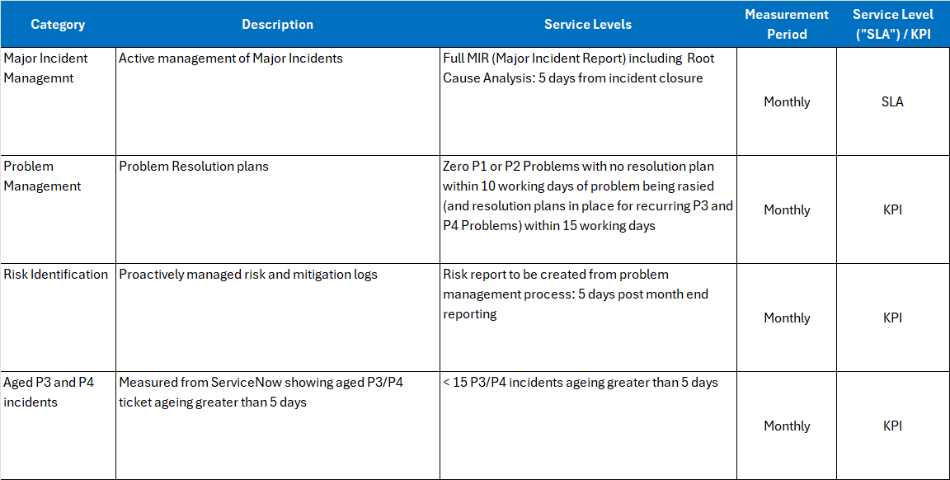

Service Level Objectives
The implementation and benefits of introducing SLO’s will achieve the following:

- Continuous Monitoring: Implementing SLOs will involve continuous monitoring of the performance and availability of critical business processes. This proactive approach will help in identifying potential issues before they escalate, ensuring a more reliable and efficient service delivery.

- Data-Driven Insights: SLOs will provide valuable data-driven insights into the performance of digital services. This information will be used to make informed decisions, optimize processes, and drive continuous improvement.

- Enhanced Customer Experience: By focusing on the availability and performance of our critical business processes, SLOs will help in delivering a superior customer experience. This aligns with Scottish Water's commitment to providing great value and service excellence to its customers and communities.

- Support for Strategic Goals: SLOs are designed to support Scottish Water's strategic goals, including the drive towards net zero. By ensuring that digital services are reliable and efficient, SLOs contribute to the overall sustainability and success of the organisation.

The primary SLO is the overall availability of the digitally enabled business processes that in turn will align with Service Level Indicators (SLI’s), these being the individual digitally enabled business processes.
The measurement period will cover availability hours throughout a full month and align with the following principles:
- Calculate the uptime hours, which is the amount of time the system has been operational without any issues.
- Calculate the downtime hours, which is the amount of time the system has experienced outages or issues.
- Add the total downtime to the uptime hours to get the total observation time.
- Divide the uptime hours by the total observation time and multiply by 100 to get the percentage of availability.
- Consolidate all the SLIs availability measures to provide an overall average availability time for all agreed digitally enabled business processes.

The Service Levels that the Partners are required to achieve for the Services are set out in the table below. These are only 10 examples of critical digitally enabled business processes and through the transition period we will identify how many will be included within the SLO measurement:

Table 51
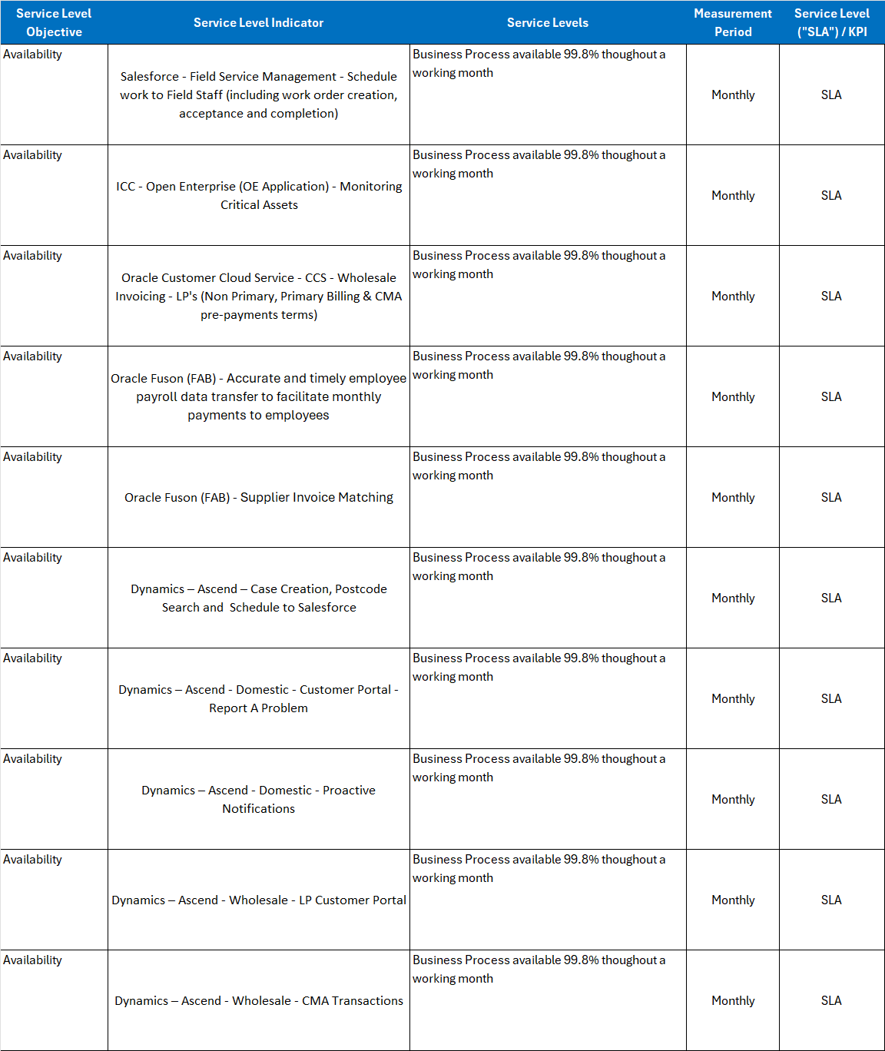

The availability Service Level Agreement (SLA) supporting each Service Level Indicator (SLI) will be set at 99.8%. Additionally, the overall SLA supporting the Service Level Objective (SLO) for the combined average availability will also be maintained at 99.8%.
Table 52
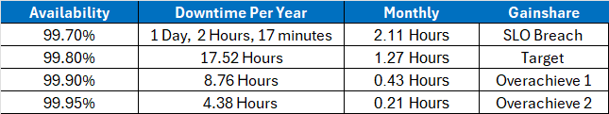
In recognising the criticality of this measure Scottish Water will introduce a gainsharing system for overachieving the combined availability measure of 99.8% that will be developed during the ITN process.
This high level of availability ensures that critical digitally enabled business process journeys are consistently reliable and meet the expectations of Scottish Water's business success measures. By setting such stringent SLAs, Scottish Water demonstrates its commitment to providing exceptional service and maintaining robust operational performance.
Digital Customer Experience Measure (DCEM)
This aggregated experience score is a composite metric that combines various individual experience scores into a single, overall score. This score is used to provide a holistic view of the overall experience, whether it be customer experience or digital experience. The aggregation process will involve averaging or otherwise statistically combining multiple individual scores to reflect the general sentiment or performance and demonstrate a commitment to providing exceptional service and maintaining robust operational performance.
Figure 5
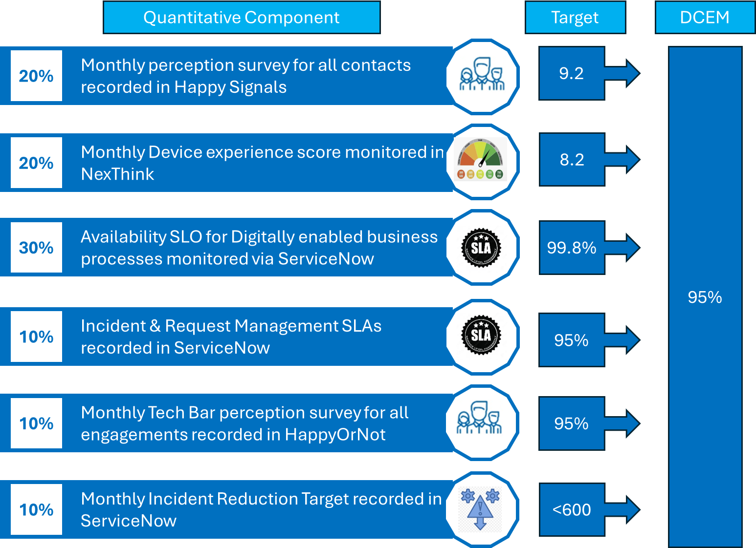

General Application Management Measures
Managing the overall integrity of an application involves ensuring that the application remains secure, reliable, and performs optimally throughout its lifecycle. This includes various aspects such as security management, performance monitoring, incident management, and compliance with policies and standards.
The Service Levels and Key Performance Indicators that the Partner is required to achieve for the Services are set out in Table 53 below:

Table 53
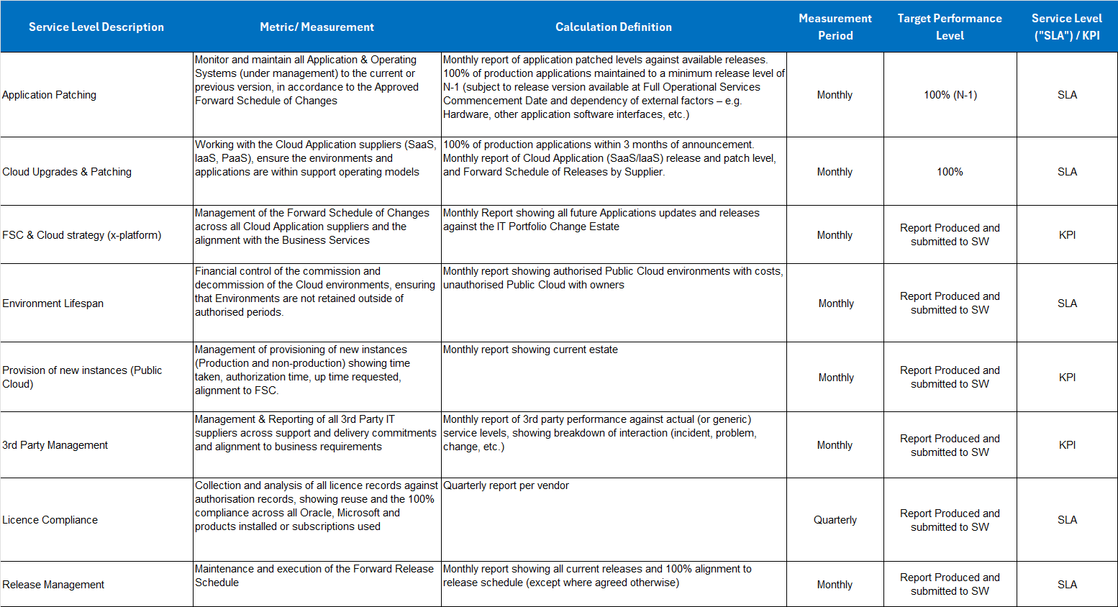
These SLAs and KPIs will help in ensuring that the application management services are effective, efficient, and aligned with the strategic goals of Scottish Wate

General Digital Experience Centre Measures
Delivering a quality Digital Experience Centre is essential for ensuring that Scottish Water users receive efficient and effective support for their technical issues and requests.
The Service Levels and Key Performance Indicators that the Partner is required to achieve for the Services are set out in Table 54 below:

Table 54
